Internet of Things - Microsoft Defender for IoT HOL

# Architecture Diagram

During this workshop we will be focusing on simulating traffic by playing some Packet captures, visualizing and analyzing the data on the sensor console. We will also integrate our sensor with Microsoft Sentinel, to explore alert handling, and for writing queries to help with alert investigation, This Hands-on-Lab (HOL) will focus on securing your facilities. The scenario below is one of many you would apply these lessons to, other scenarios are Oil, Gas, Utility, and Energy companies.

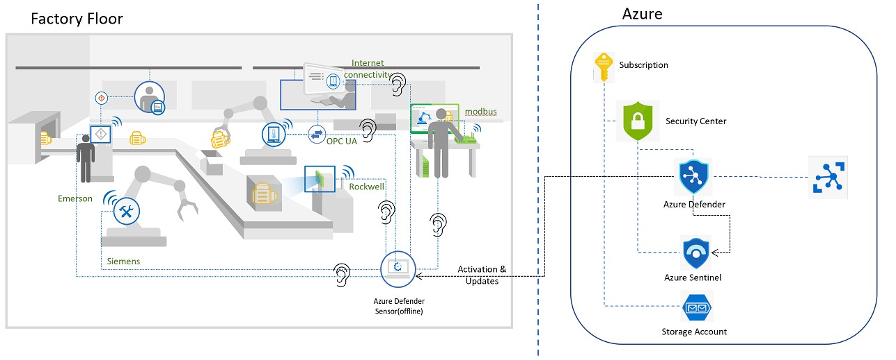

Contents

Architecture Diagram 1

Exercise #1: Enabling Defender 2

Task 1: Create an Azure Subscription 2

Task 2: Enabling Microsoft Defender for IoT on the Subscription 3

Exercise #2: Deploy the Sensor in Azure 5

Task 1: Create a Resource group to automatically deploy your sensor, storage account and network security group to 5

Task 2: Access your Virtual Machine. 7

Task 3: Access your sensor via the console 11

Exercise #3: Simulate Data in your sensor 16

Task 1: Enabling the PCAP Player 16

Task 2: Play PCAP files 18

Exercise 4: Analyzing the Data 19

Task 1: Visualize on the Device Map 19

Task 2: View the associated Alerts 22

Task 3: Device Inventory 24

Task 4: View the Event Timeline 25

Task 5: Data Mining 25

Task 6: Generate a Risk Assessment report 27

Exercise 5: Cloud Connect your sensor 27

Task 1: Create the cloud connected sensor on the Cloud Management portal 28

Task 2: Upload the activation file to cloud connect your sensor. 28

Task 3: Verify Cloud connection 29

Exercise 6: Integrate with Microsoft Sentinel 30

Task 1: Connecting Data Connectors 30

Task 2: Acknowledge Alerts and Re-run PCAPs 35

Task 3: Sentinel interaction with IoT Incidents 36

Task 4: Kusto Query Language to Find Alert Details 38

Exercise 6: Clean Up 39

Task 1: Delete resources 39

# Exercise #1: Enabling Defender

## Task 1: Create an Azure Subscription

1. Use this link to set up your free trial: <https://azure.microsoft.com/en/free>.
2. Click on **“Start Free”** as shown in the image

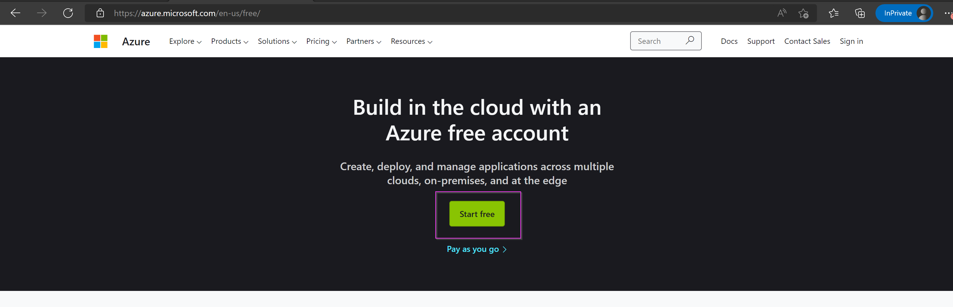

1. Follow the prompts to **Create your Account** and **Sign in.**
2. On the Azure Portal, go to type **“Subscriptions”** on the search bar on top.

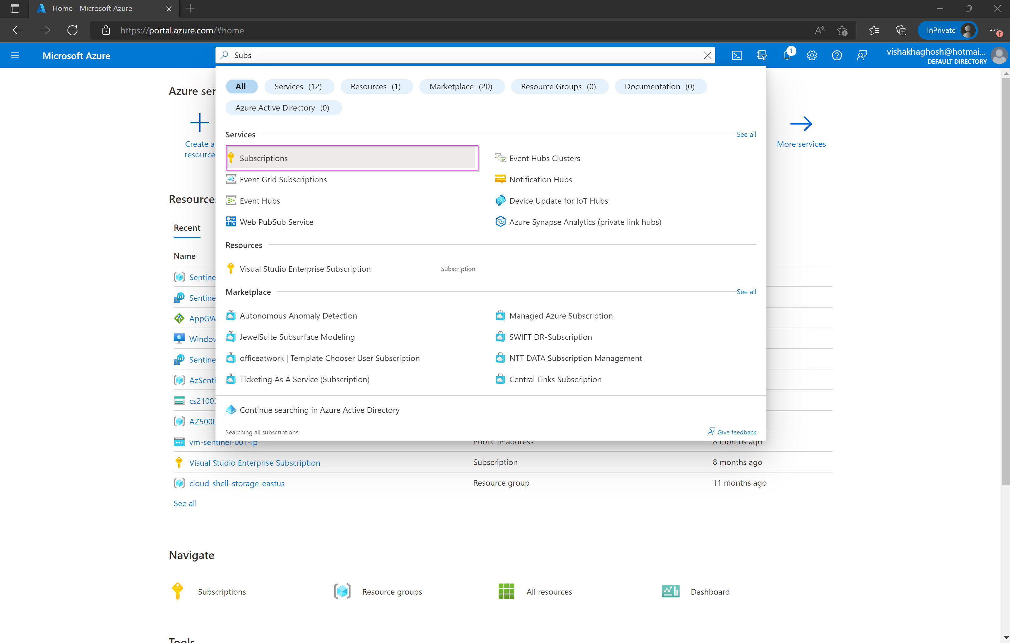

1. Your subscription will show up on the list of **“Subscriptions”.**

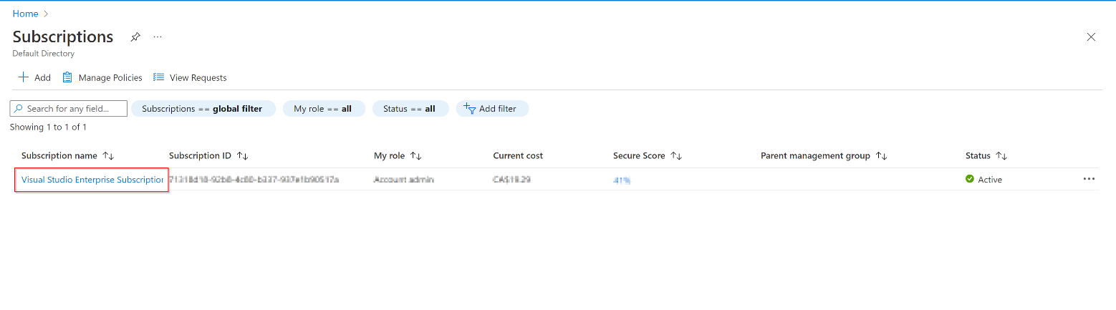

## Task 2: Enabling Microsoft Defender for IoT on the Subscription

1. In the [Azure Portal](https://portal.azure.com/#home), search for **Microsoft Defender for IoT**. Select **Microsoft Defender for IoT** in the popup window, to open the Microsoft Defender for IoT Page.

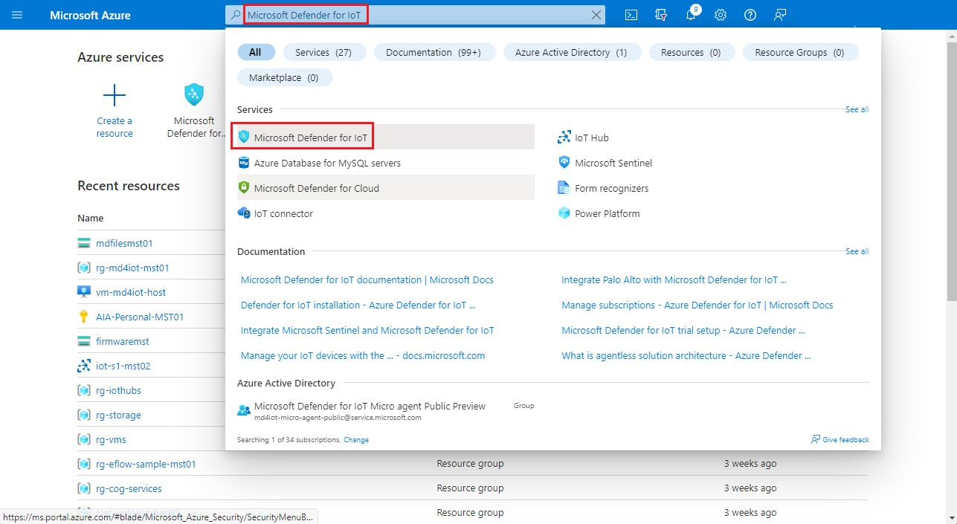

1. On the Defender for IoT page, in the **Getting Started** section, select **Pricing**.

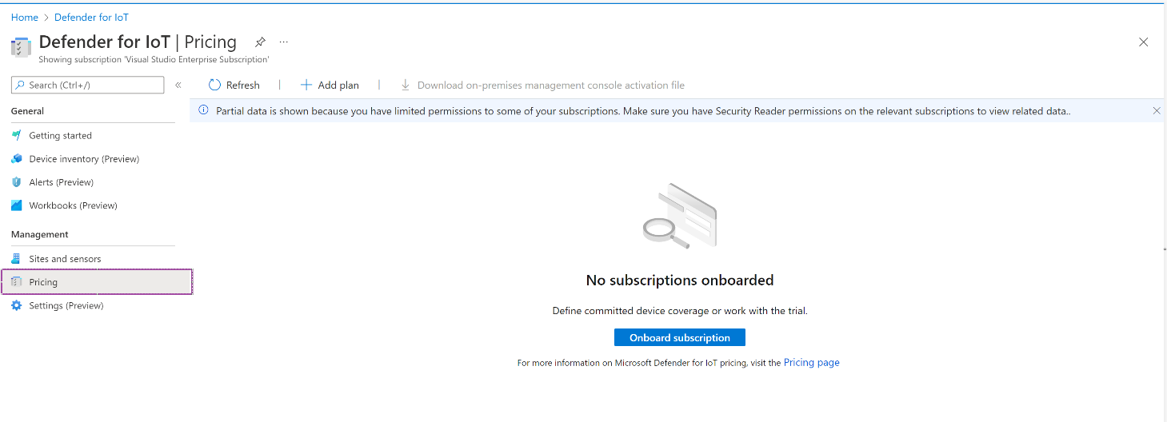

1. On the **Pricing** page, select **+Add Plan**.

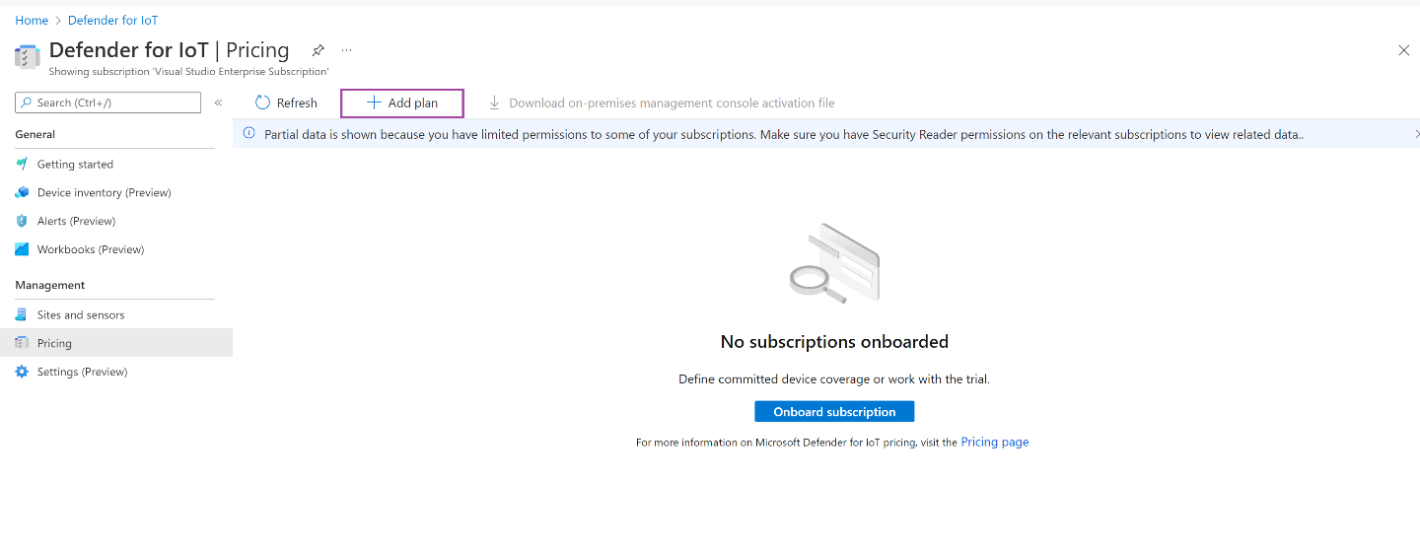

1. In the popup screen, select:
2. **Purchase Method:** Trail
3. **Subscription:** pick the trial subscription you created
4. Click **“I accept the terms”**, followed by “**Save”**.

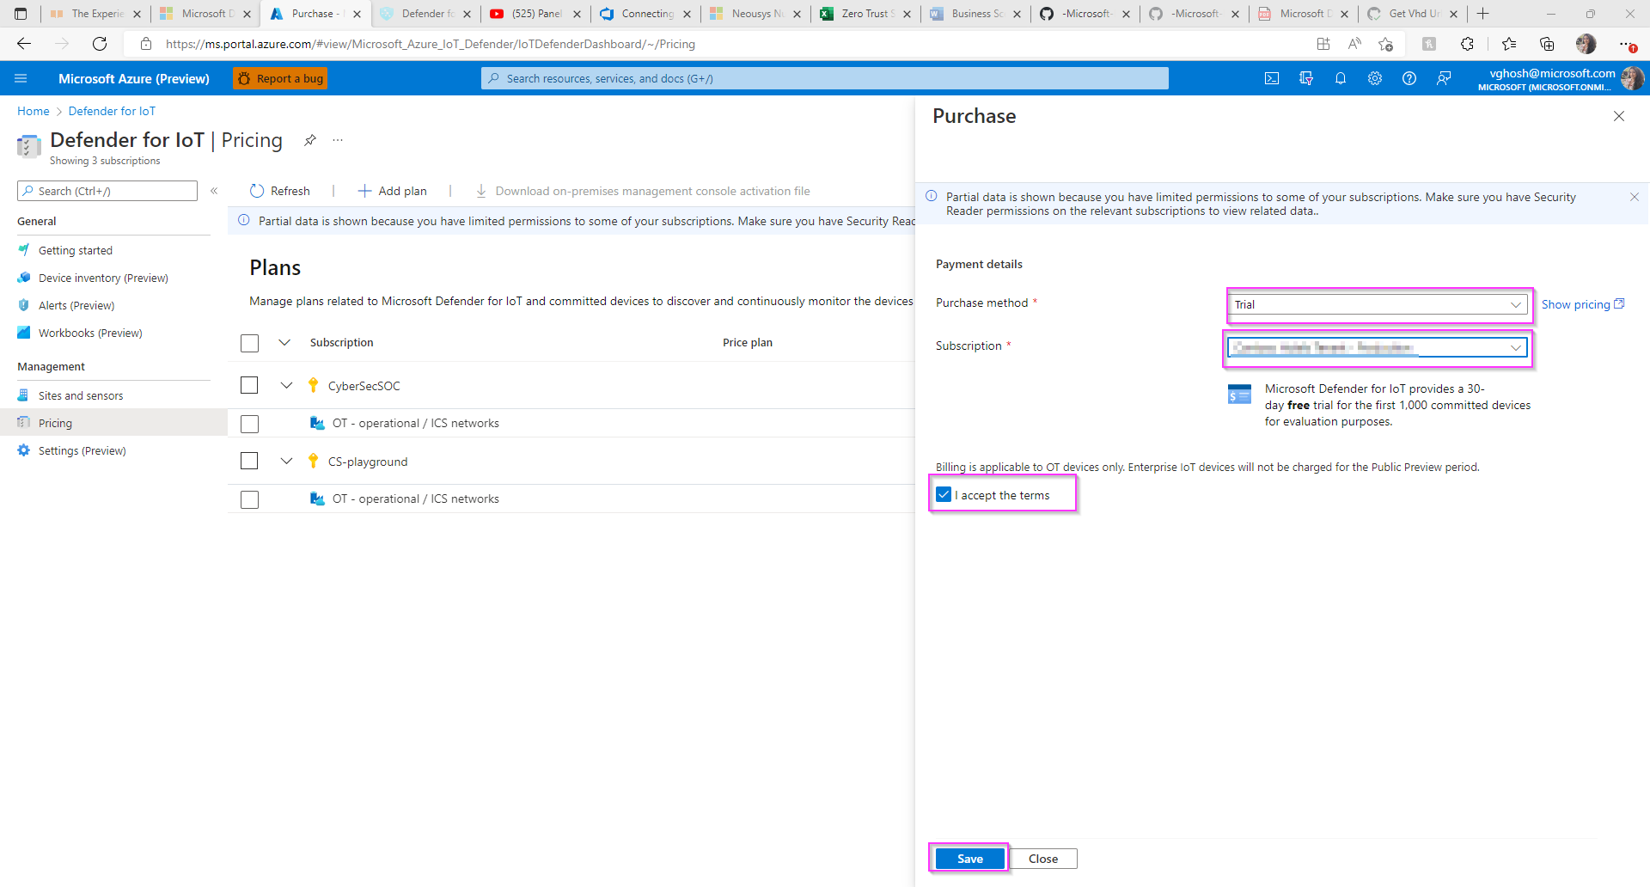

You now have a valid Microsoft Defender for IoT Trial with ***1000 committed devices***. These devices represent all those equipment/sensors connected to your network in the facility you are analyzing. This configuration allows you a ***30-day trial for free.***

# Exercise #2: Deploy the Sensor in Azure

## Task 1: Create a Resource group to automatically deploy your sensor, storage account and network security group to

For the deployment, a **VHD file is used**. The link for the IoT sensor installation is in the email you have received.

***Please note - This link is private and will expire in 3 days.***

1. Click the link below to generate a template deployment installation

<https://ms.portal.azure.com/#create/Microsoft.Template/uri/https%3A%2F%2Fraw.githubusercontent.com%2FAzure%2F-Microsoft-Defender-for-IoT%2Fmain%2FHands%2520on%2520Lab%2520Documents%2FAzureDeploy.json>

1. You will be taken to a custom deployment page that looks like the image below:

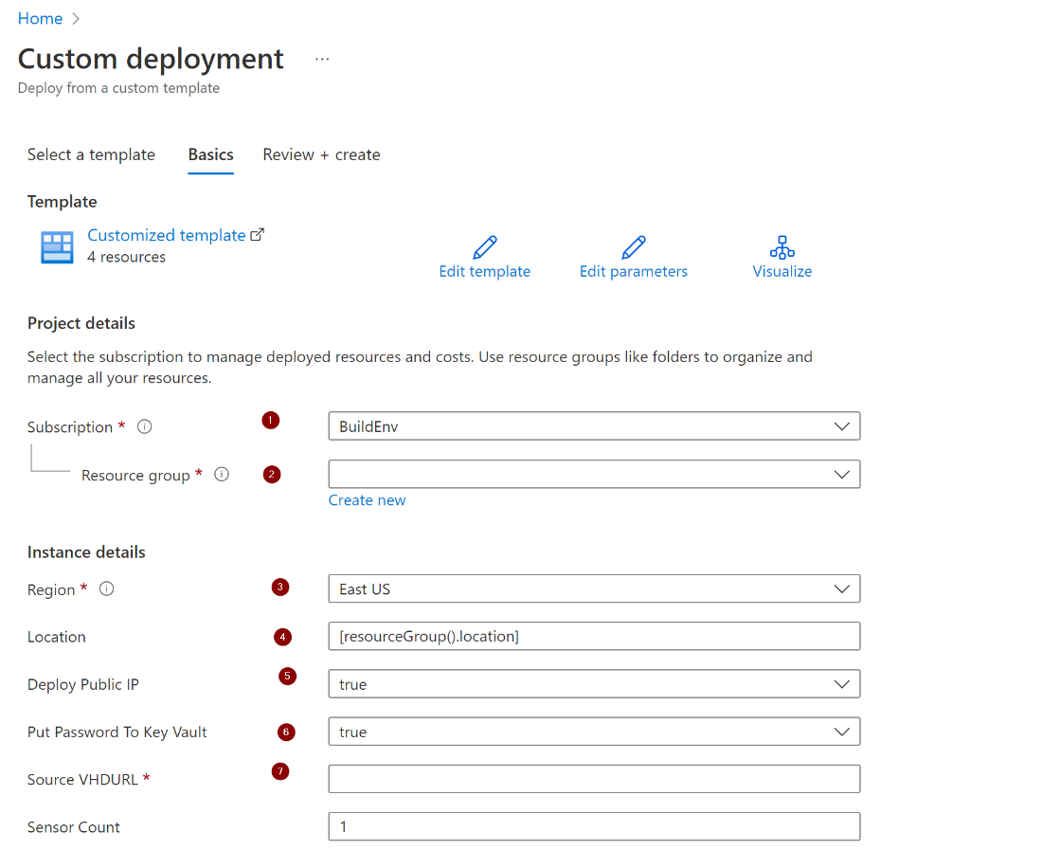

1. Please select your **Subscription** liked to the trail service.
2. Please create a new **Resource Group** (Use the hyperlink below the box). We recommend creating a new one to easily identify the relevant resources of the trail service.
3. Please select the **Region** (Time zone) to which you are deploying the trail service to.
4. Please leave the **Location** box with its default value, no need to change it.
5. **[OPTIONAL]** Set the **Public IP** option to **"true". However, doing this will open your sensor to the internet. If you have alternate ways to publish the sensor to end users, then just use the internal ip by setting “Deploy Public IP” to “false”.**
6. Set this field to true if you want to store your secrets in keyvault.
7. Please paste the link of the **VHD** copied from the email into the **Source VHDURL** field.
8. Once complete please click on the **Review + Create** button Upon validation completion, proceed to click on the **Create** button to initiate the process. The process runs for approx. 30 to 60 minutes.

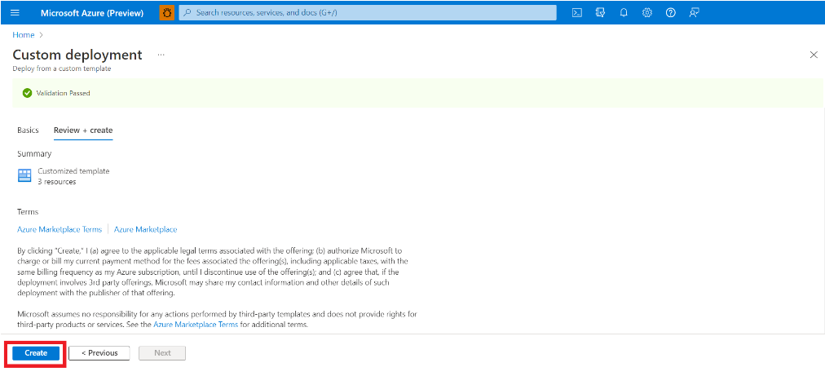

## Task 2: Access your Virtual Machine.

Option #1: If you deployed with Keyvault

1. Once the deployment is complete, click on “Go to resource group” as shown in the image below.

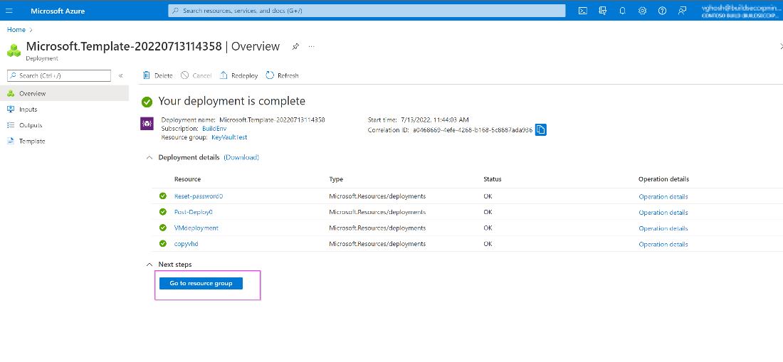

1. Go to the keyvault resource from the list.

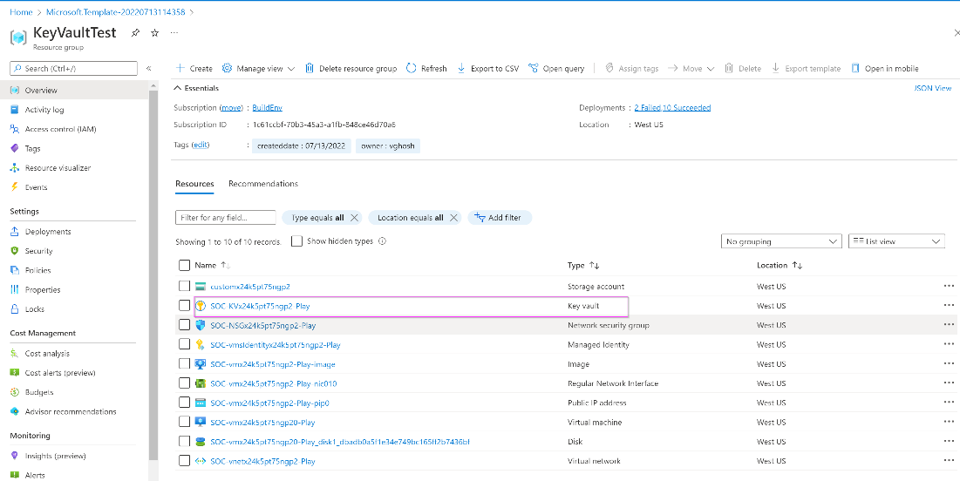

1. Click on “Access Policies” -> “Add Access Policies”.

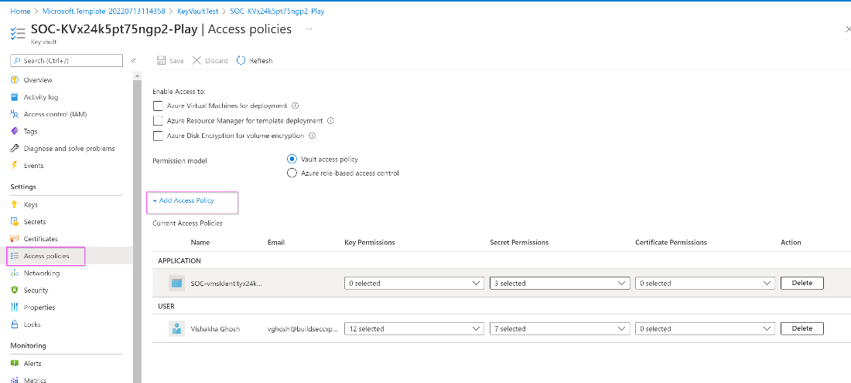

1. On “Configure from template” select “Key & Secret Management”, on “Select Principle” select “None selected” and type in your email.

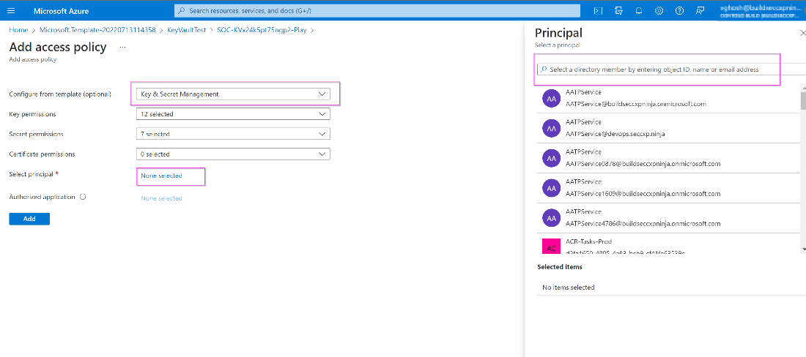

1. Go to “Secrets” and select the item on the list.

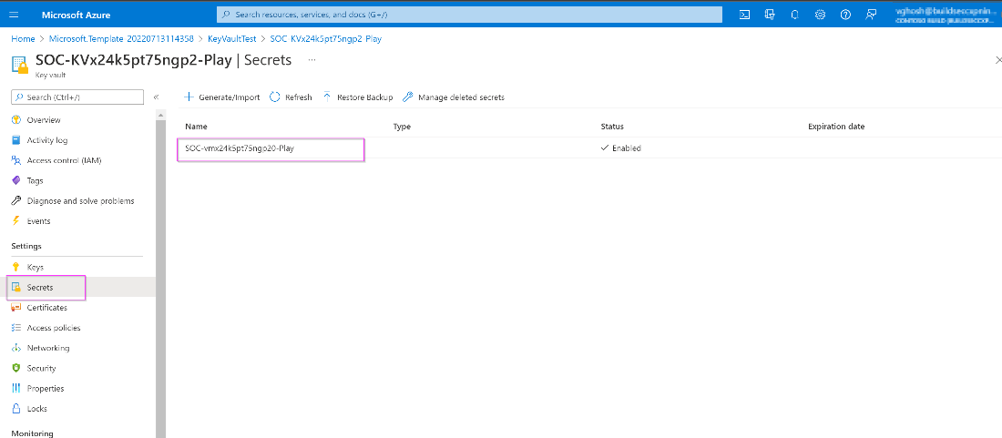

1. Click on the current version.

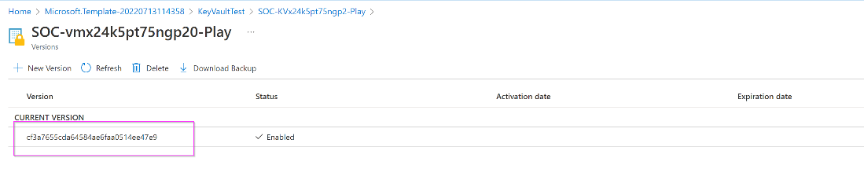

1. Copy the secret value to your clipboard.

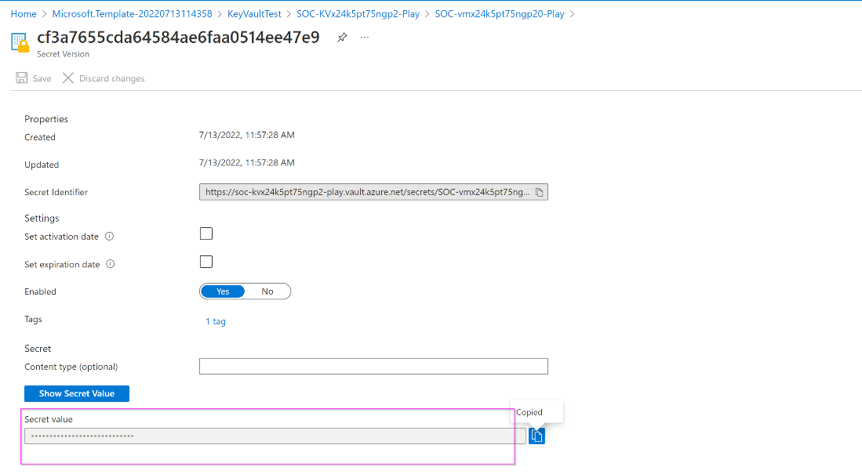

1. Go back to your resource group and select the Virtual Machine resource.

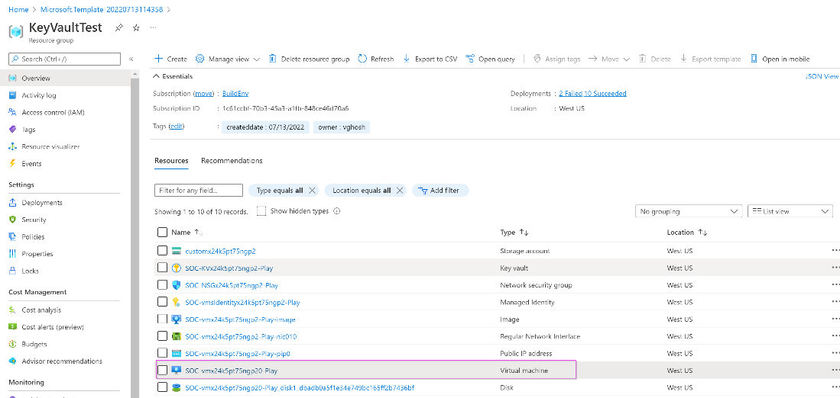

1. Make a note of the Public IP address.

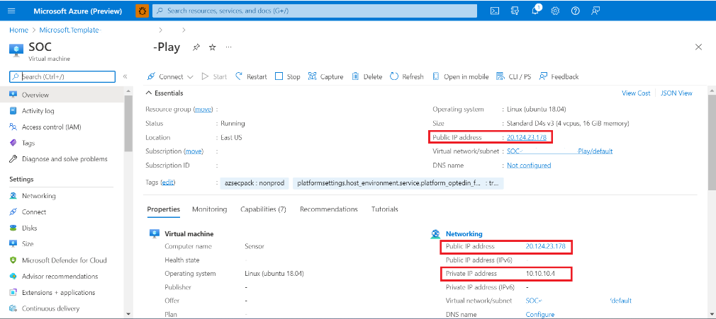

**Option #2: If you deployed without Keyvault.**

1. Once the deployment is complete, go to “Reset-password0” by clicking the button.

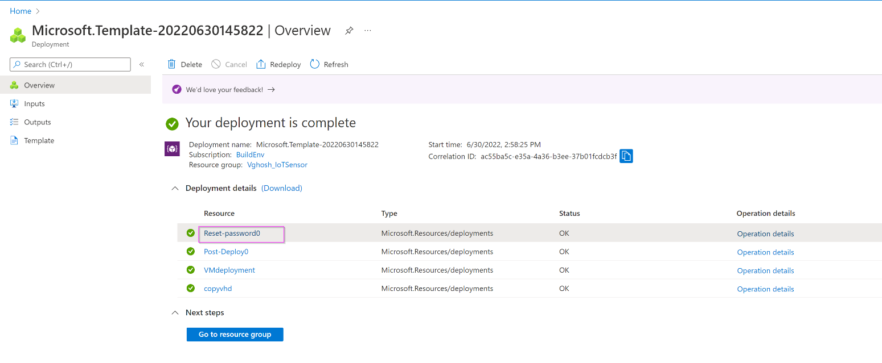

1. Copy the system generated random password from the “Password” field and make a note of the VMName.

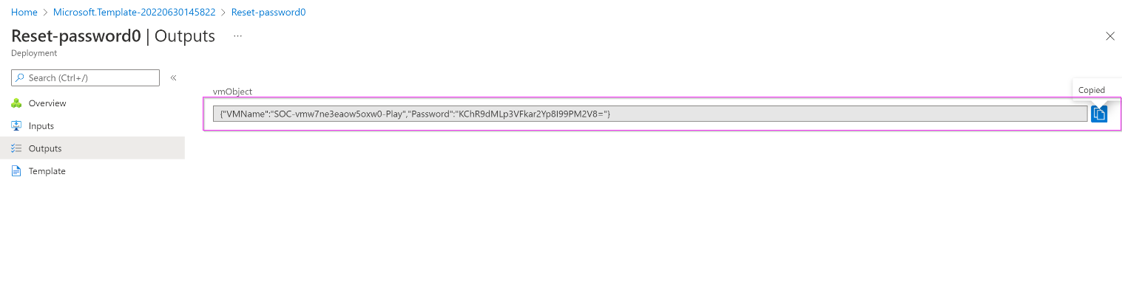

1. Click “go to resource group” from the previous screen.

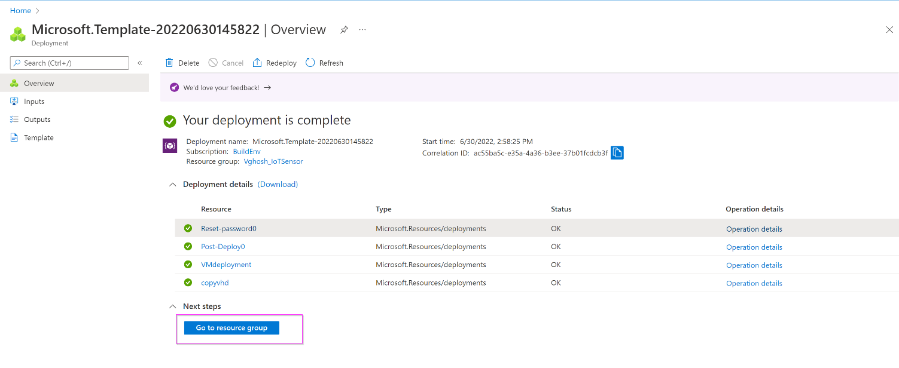

1. Select the virtual machine from the list of resources in the group.

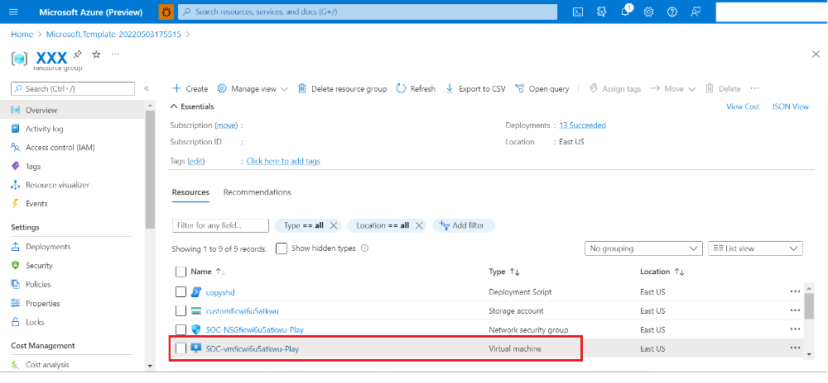

1. Make a note of the Public IP address.



## Task 3: Access your sensor via the console

1. Proceed to access the console by using the selected networking method IP (Public or IP) using https:// as shown in the image and sign in with the IP you copied in the previous step. Username is **cyberx_host** and the password is what you copied in step 2.

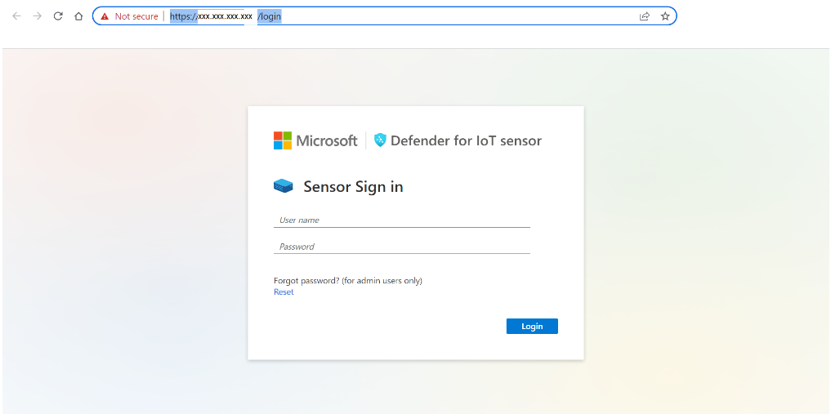

1. Upon successful login please proceed immediately to change the password by clicking on the username on the top right corner and selecting **Sign out.**

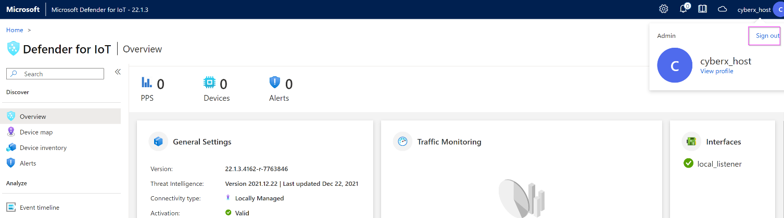

1. After signing out, please return to the Azure portal and navigate to **“Defender for IoT”**. Select **“Sites and sensors”**, select your sensor from the list, and click on **“Recover my password”.**

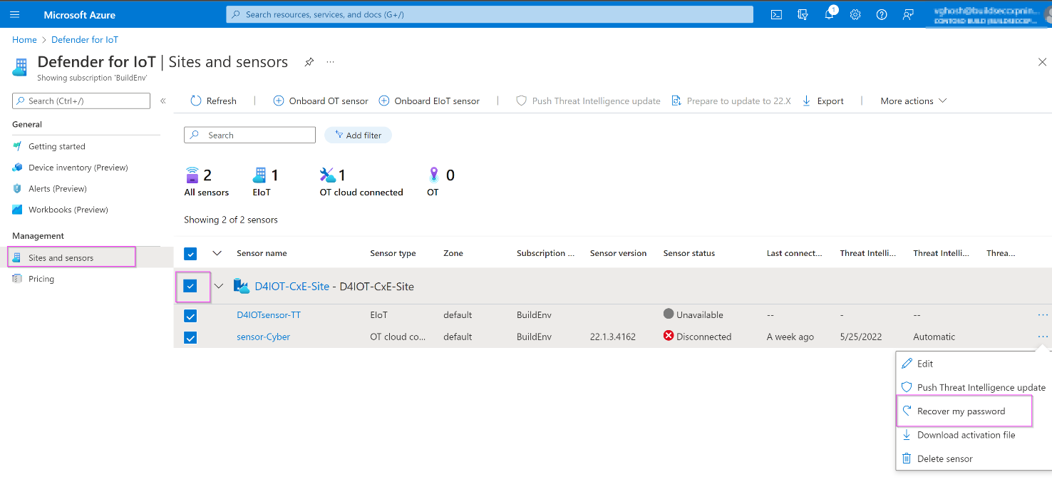

1. You will see this prompt asking for the “secret identifier”.

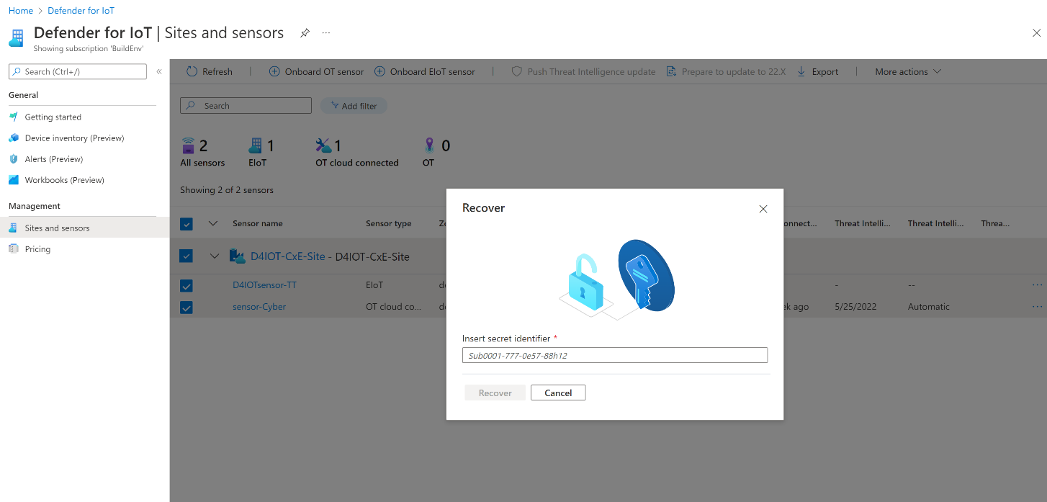

1. Return to the sensor console and type in the username followed by “Reset” as shown.

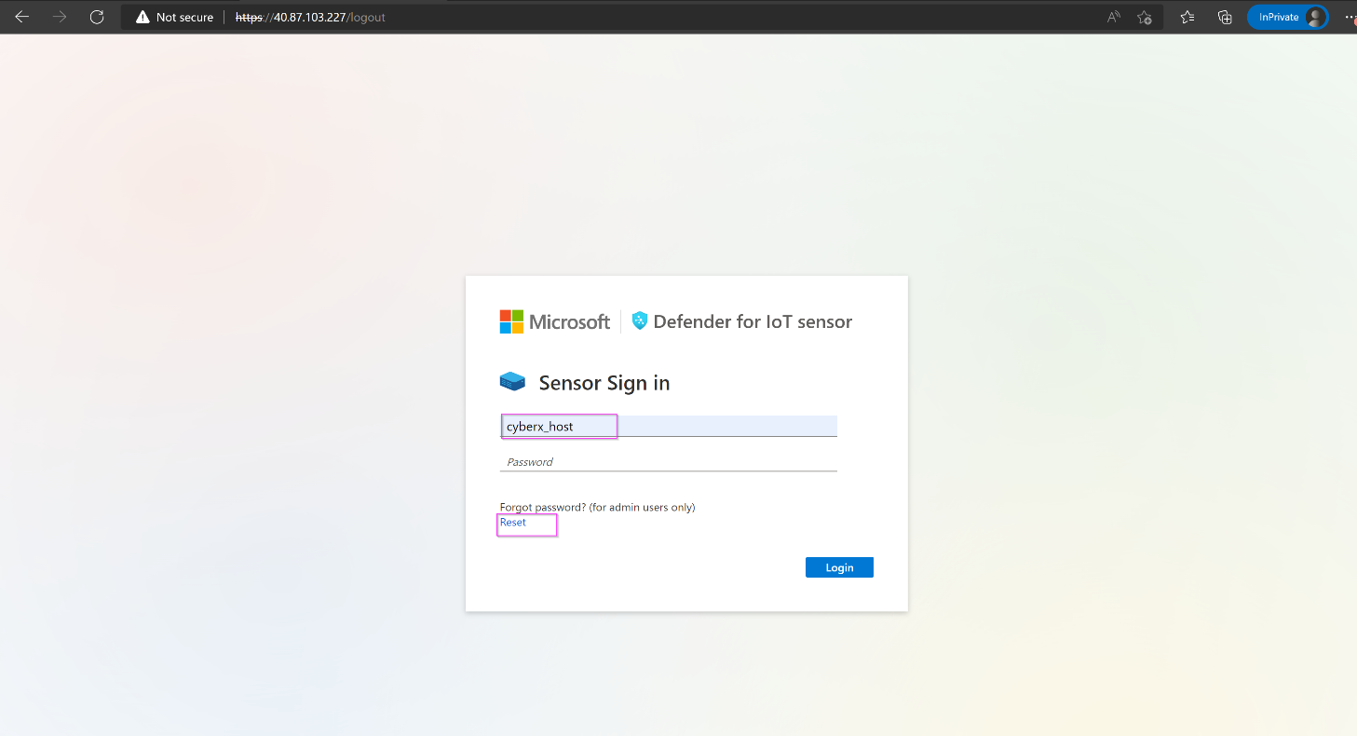

1. Copy the identifier.

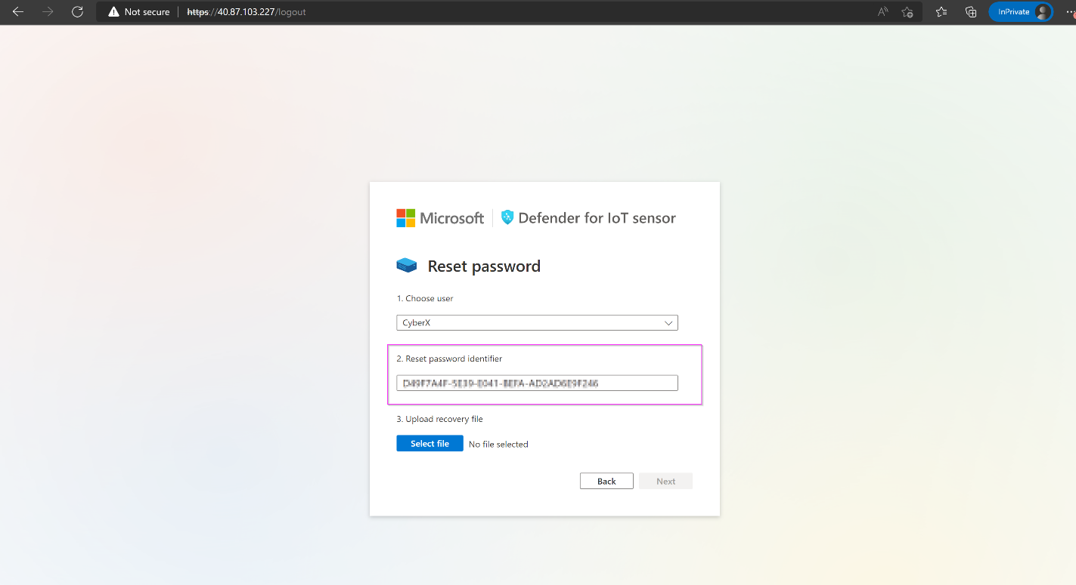

1. Paste in the box on the Defender for IoT Azure window. Click “**Recover”.**

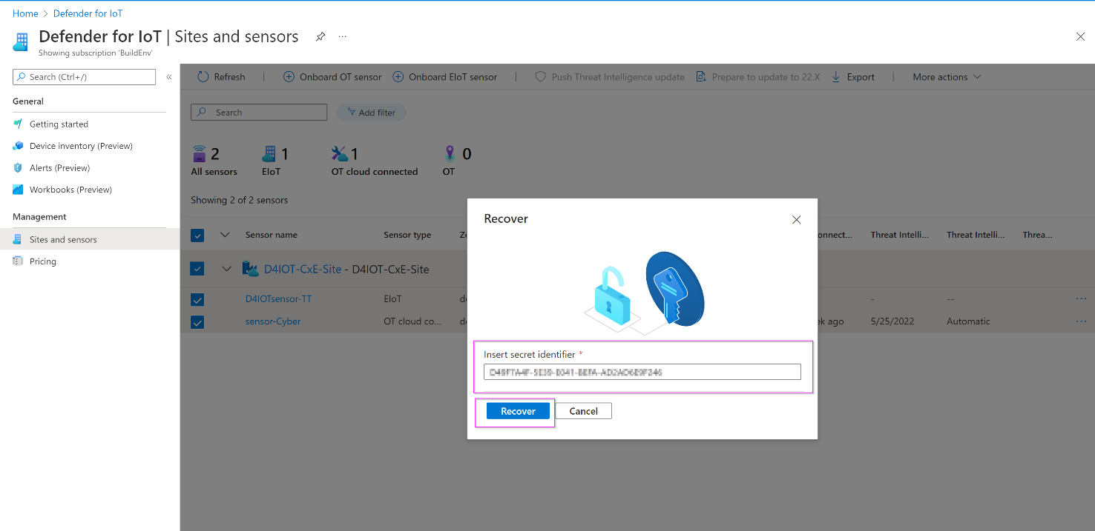

1. The *“password_recovery”* file download starts. Once the download is complete, return to the sensor console and click on **“Upload recovery file”. Do not unzip the folder.**

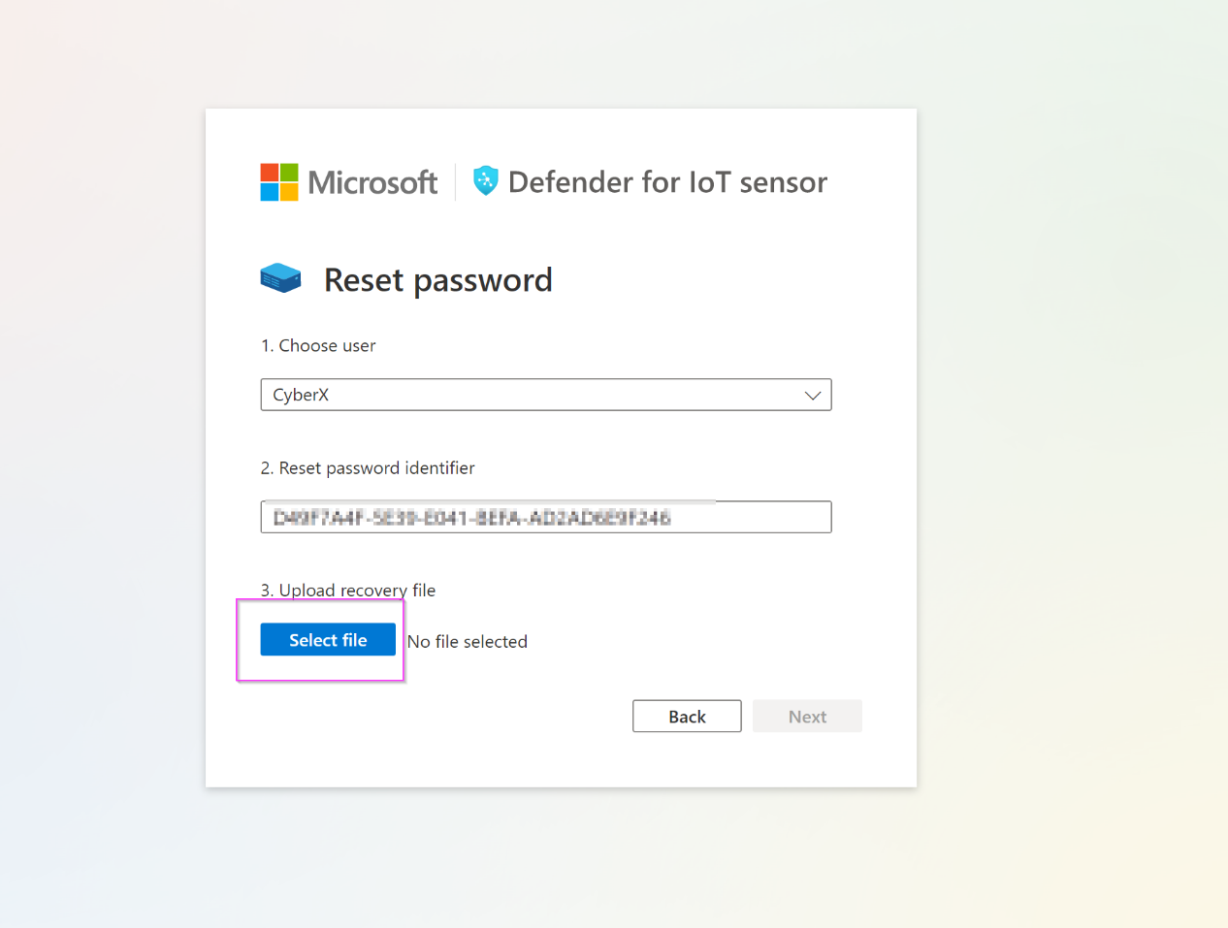

1. Click on **“Next”.**

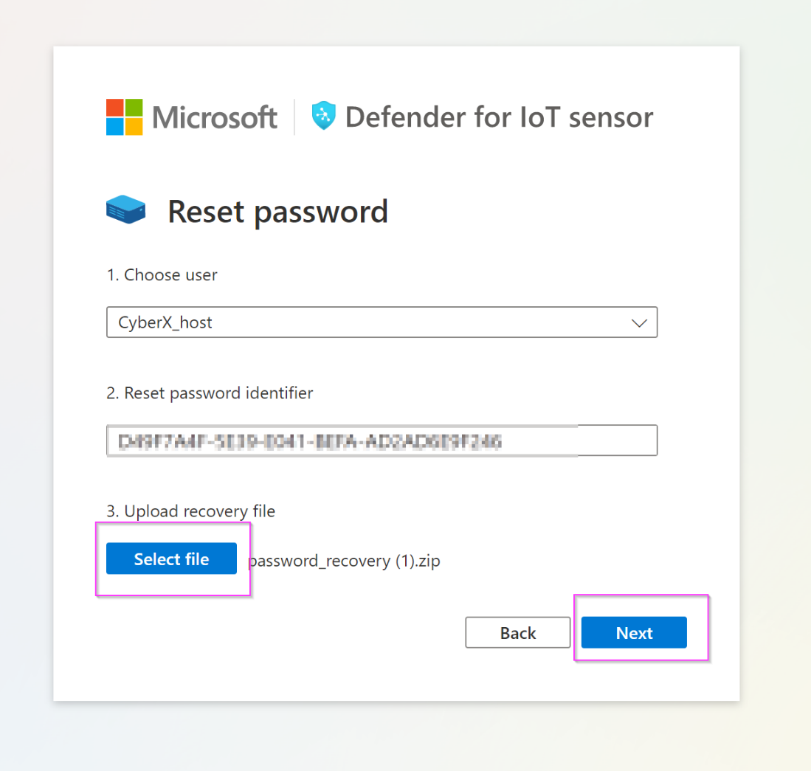

1. After uploading the file, you will be shown a temporary password on the screen. Please note it down.

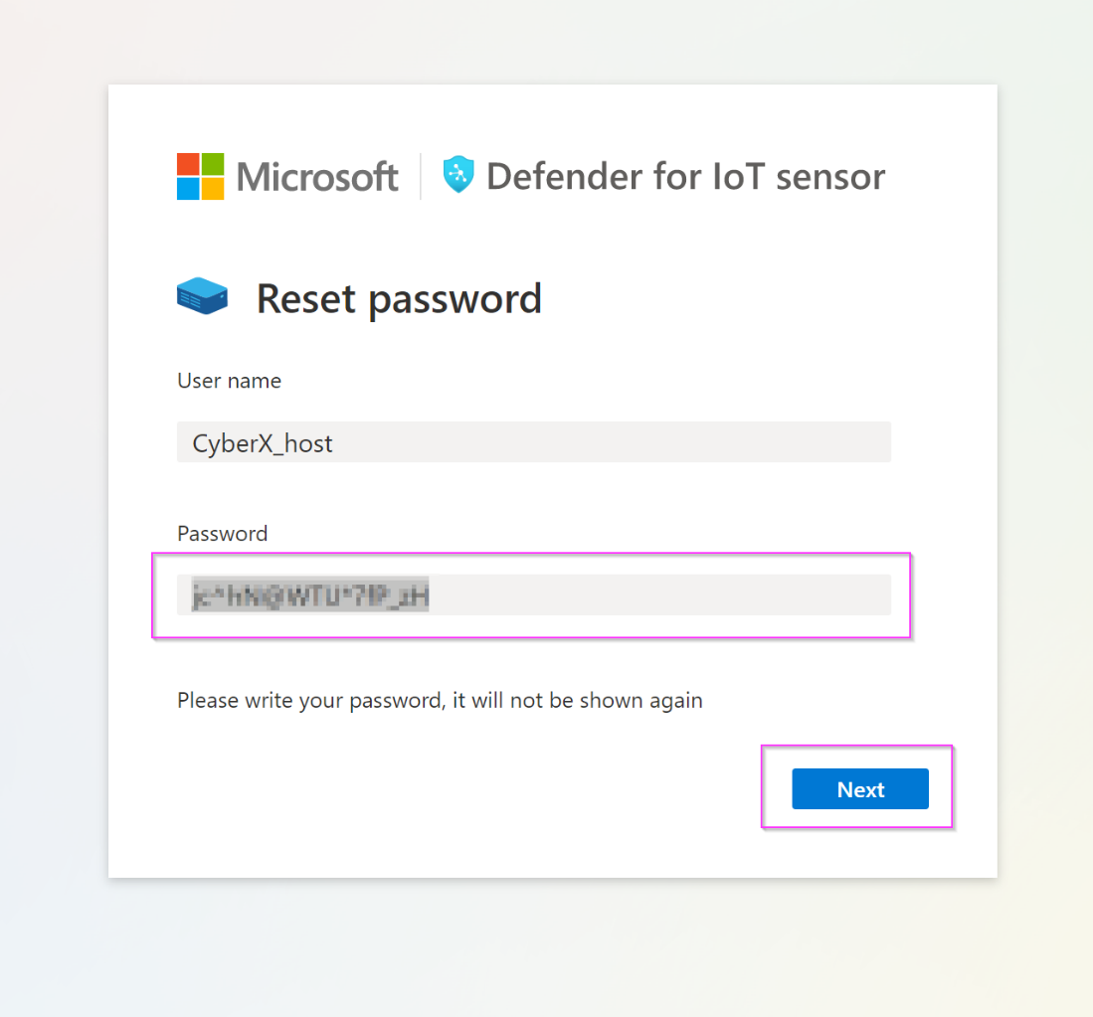

1. Log in with the new password.

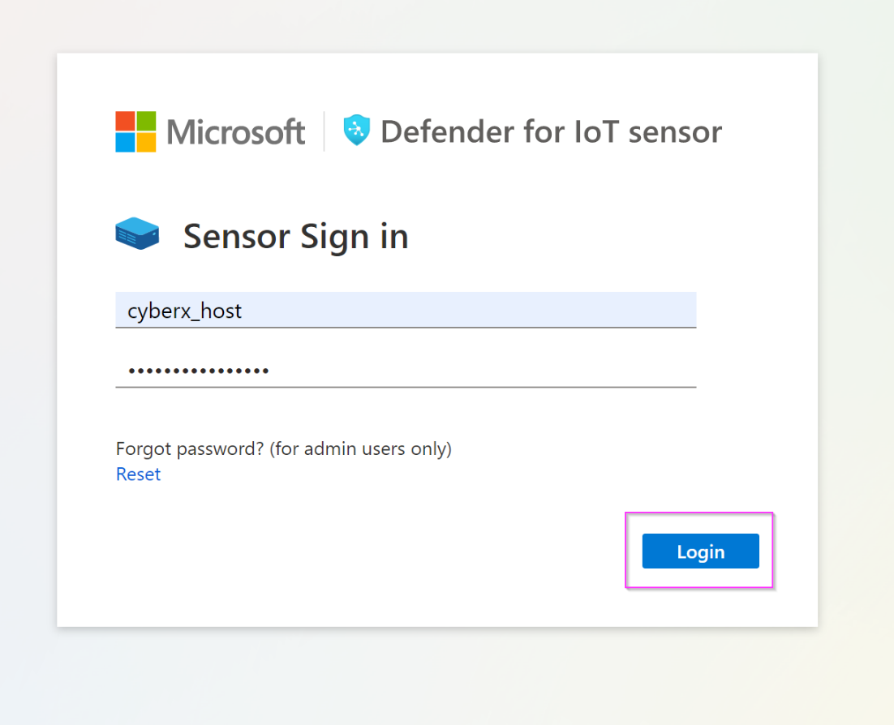

1. Repeat this step for all the usernames.

# Exercise #3: Simulate Data in your sensor

## Task 1: Enabling the PCAP Player

1. The PCAP player needs to be enabled to be visibly available for use in the UI. To do so, please select the "**System settings**" option from the scrolled down left side menu.

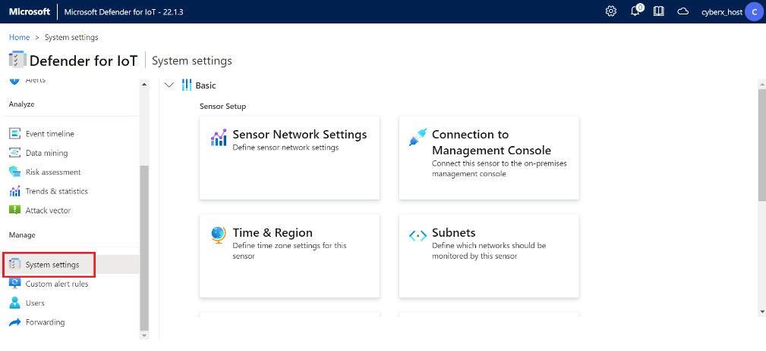

1. Scroll down to locate the **"Advanced Configuration"** option (Shown in the image below in the red square).

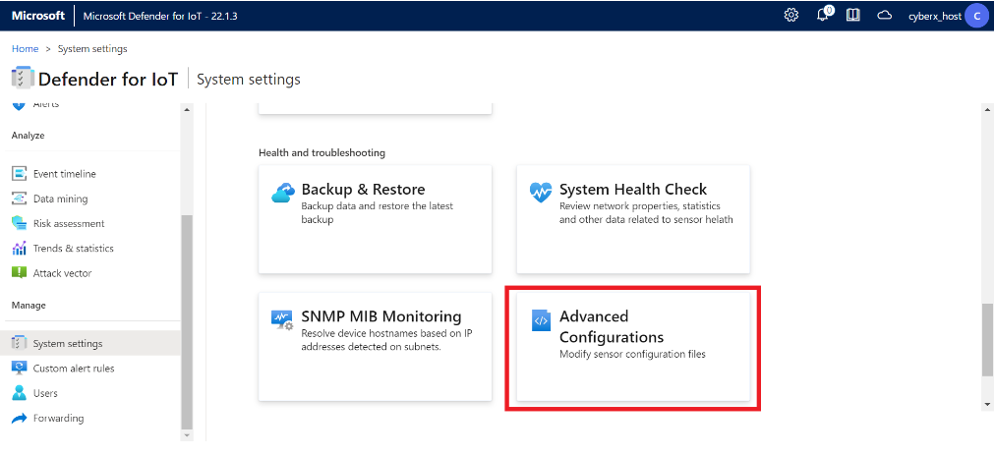

1. From “Select a Configuration Category”, select Pcaps.

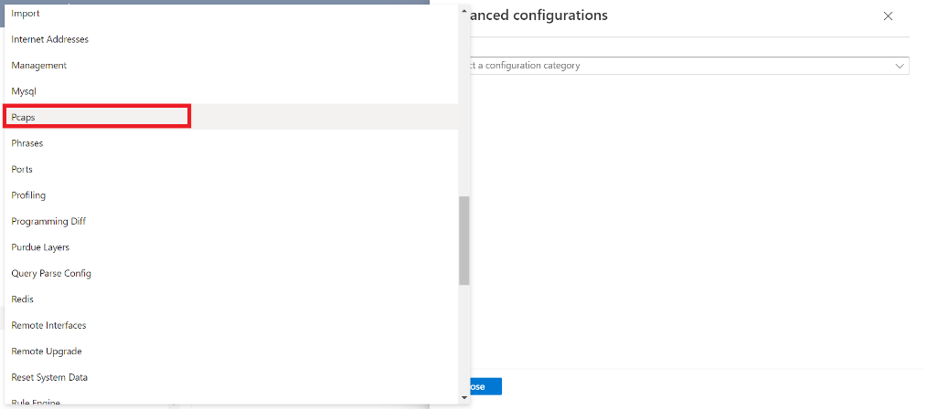

1. Scroll down to locate the "**enabled**" variable and set it to **1**. Click **Save** and approve to commit the change.

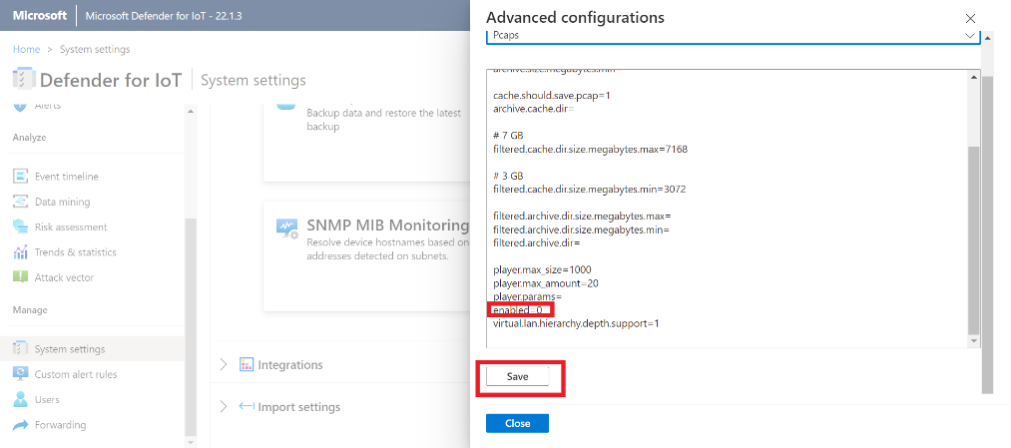

## Task 2: Play PCAP files

1. Use [this](https://github.com/Azure/-Microsoft-Defender-for-IoT/tree/main/DeploySensorV22/PCAPs) link to download the holcaps.zip folder.
2. Unzip the folder.
3. Scroll all the way down to the bottom to locate if the PCAP Player is enabled (Shown in the image below in the red top square) or not. If the PCAP player is not shown, proceed to click on the arrow next to the **Sensor Management** button (Shown in the image below in the red lower square).

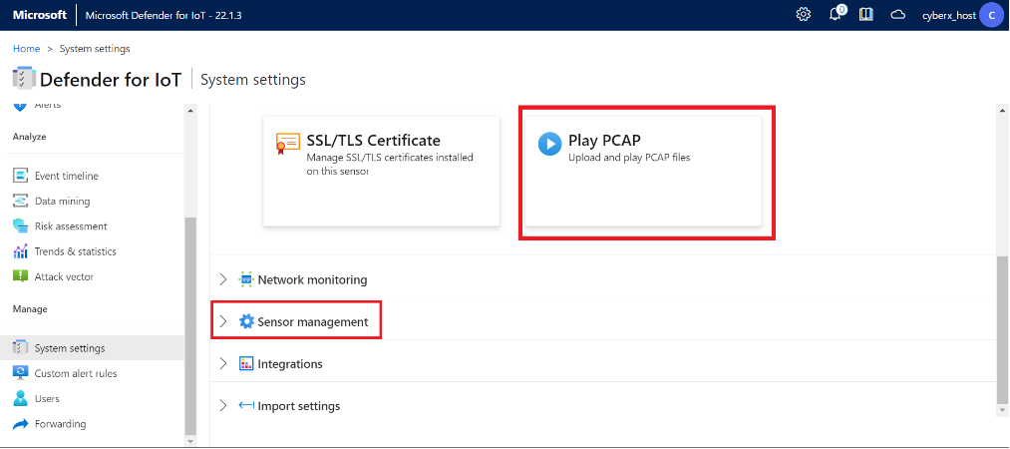

1. Click on **“Upload”** and select your Pcap files from the unzipped folder.

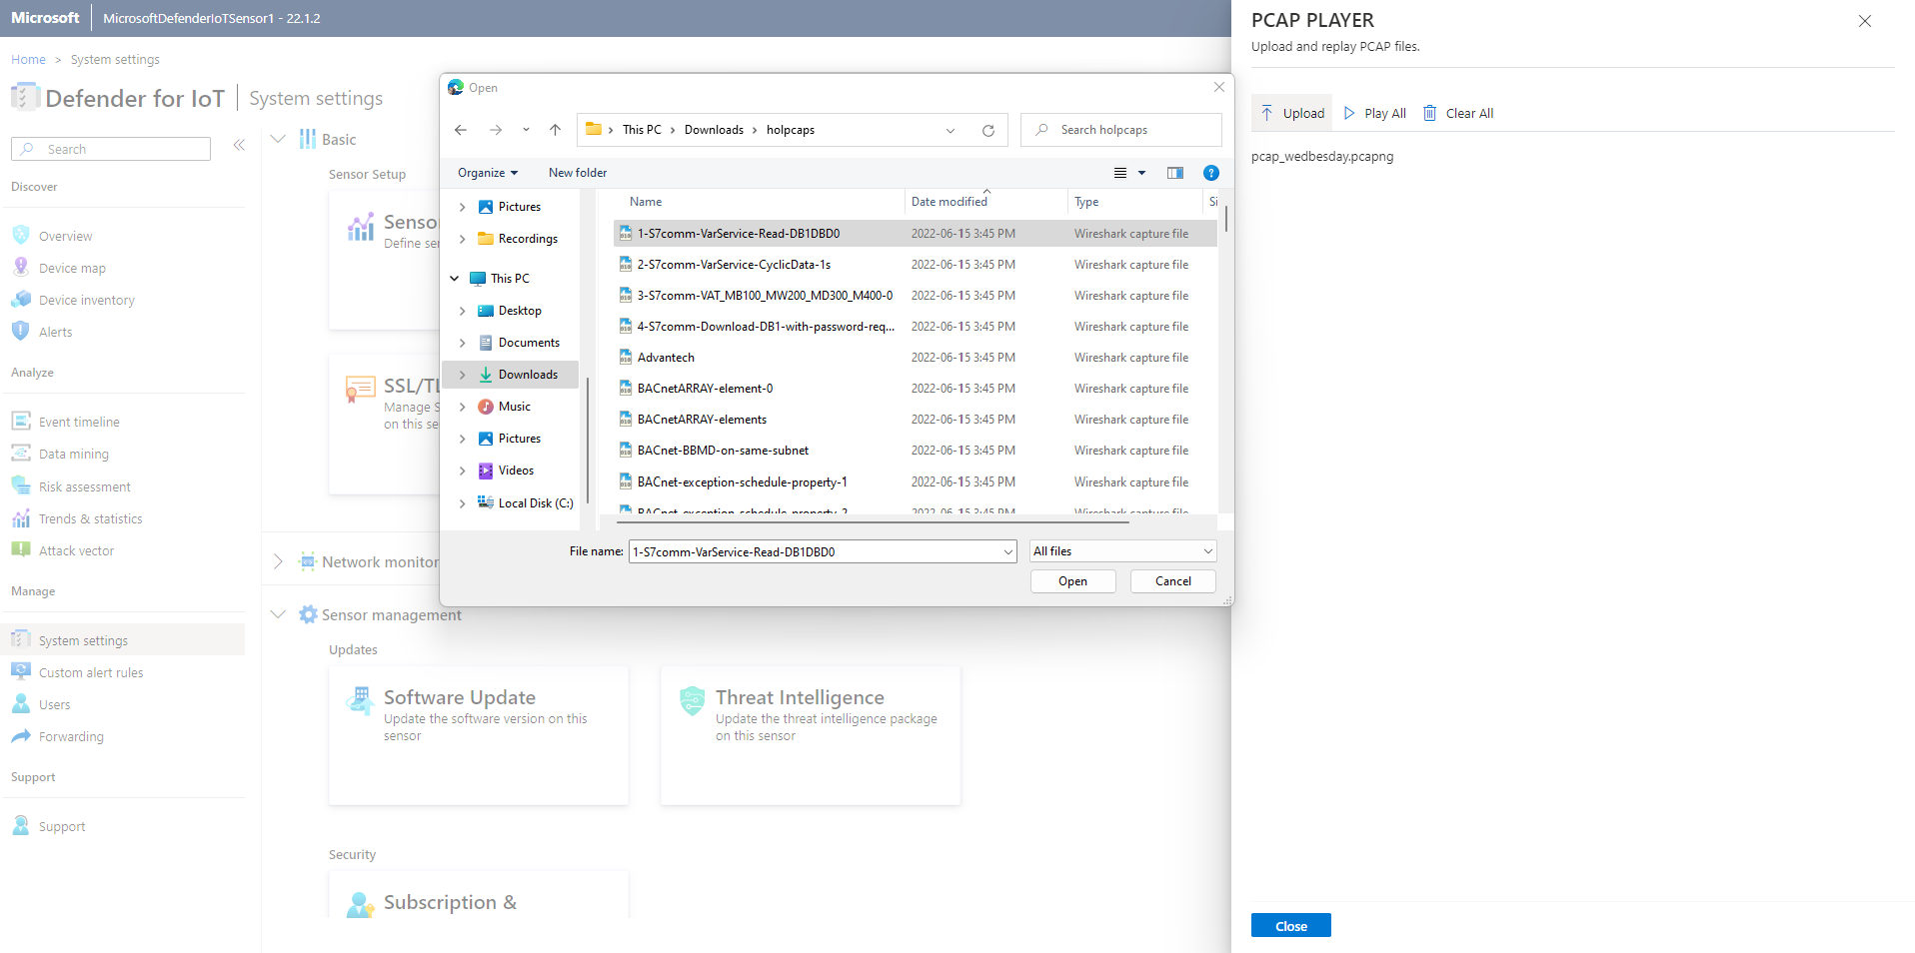

1. Click “Play All” to play the Pcaps.

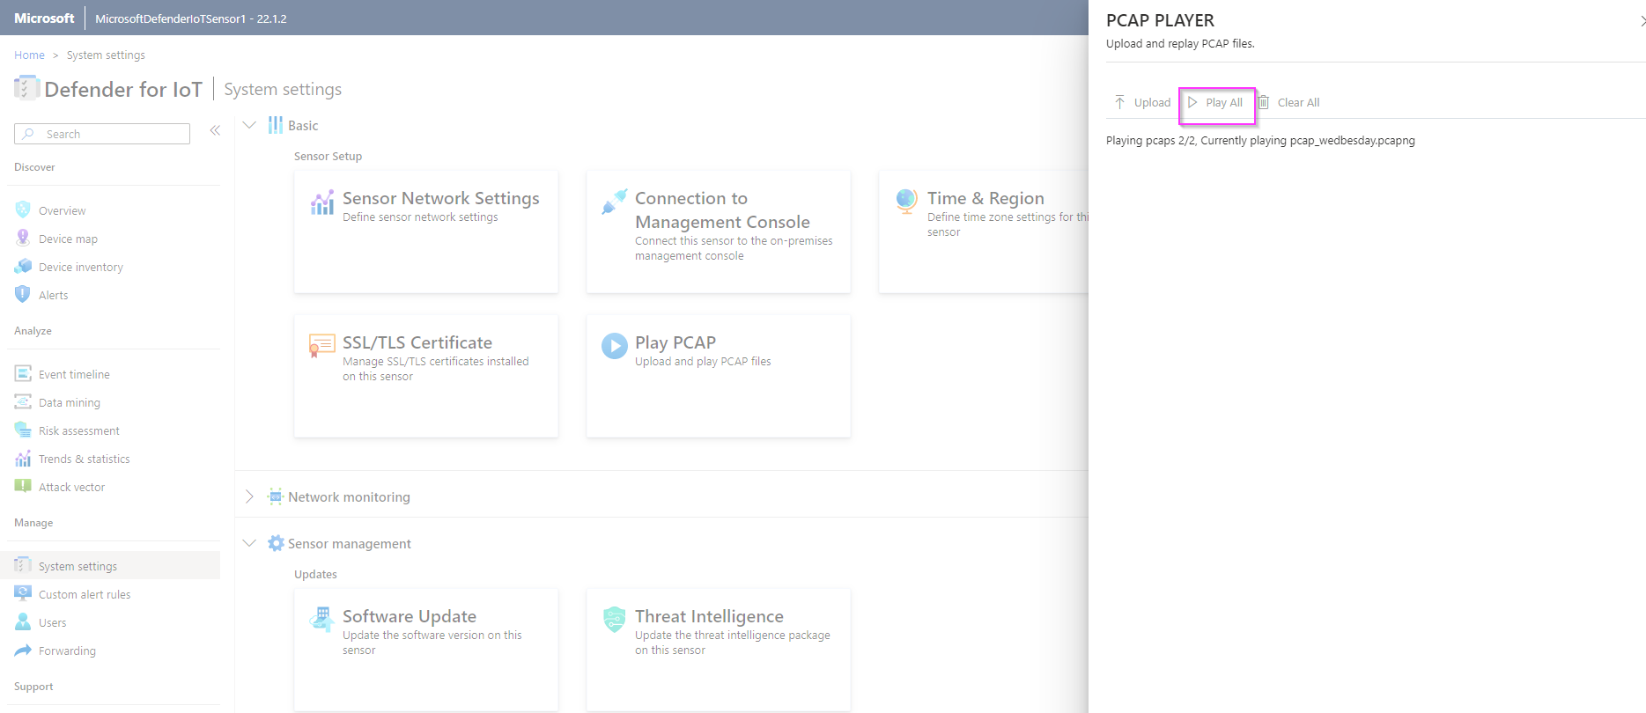

# Exercise 4: Analyzing the Data

## Task 1: Visualize on the Device Map

1. Click on **“Device Map”** from the menu on the left side.

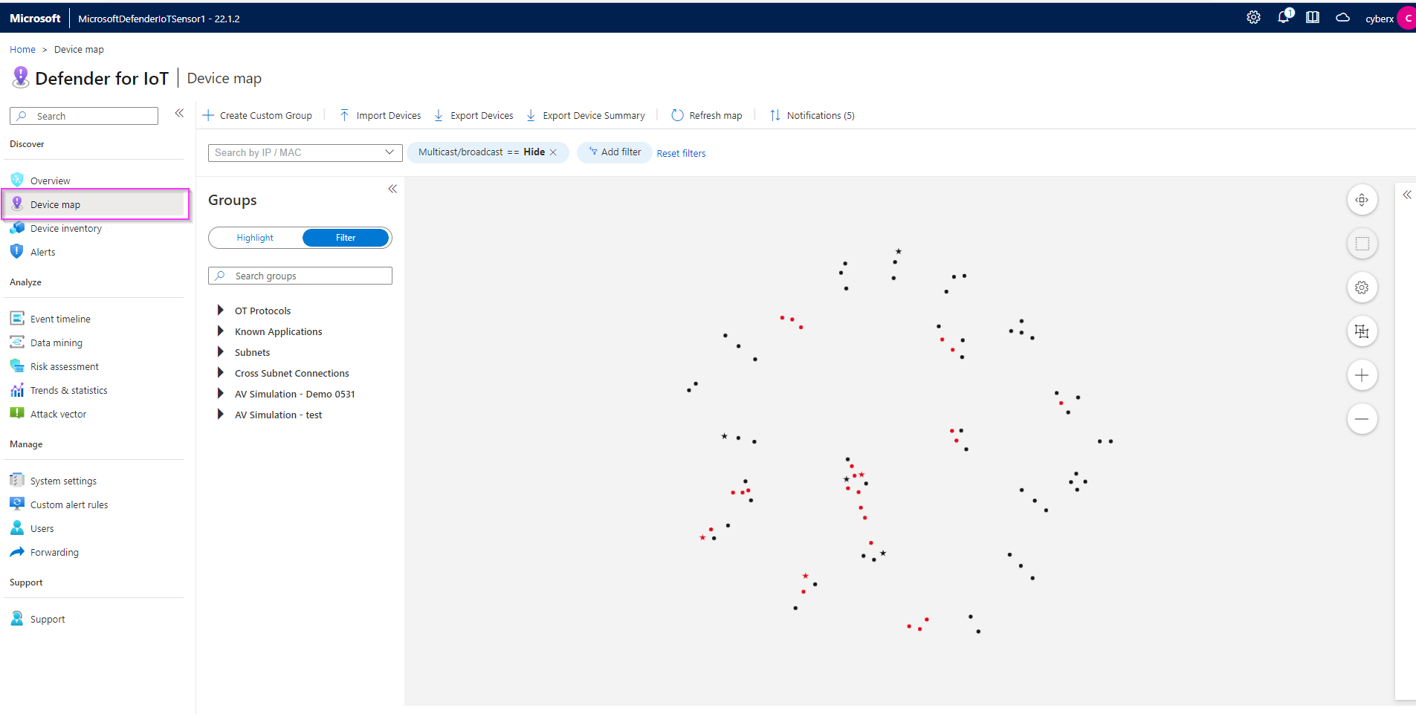

1. Click on the “Settings” option and select **Layout by Purdue** which will allow you to see the different layers between Corporate IT and site operations.

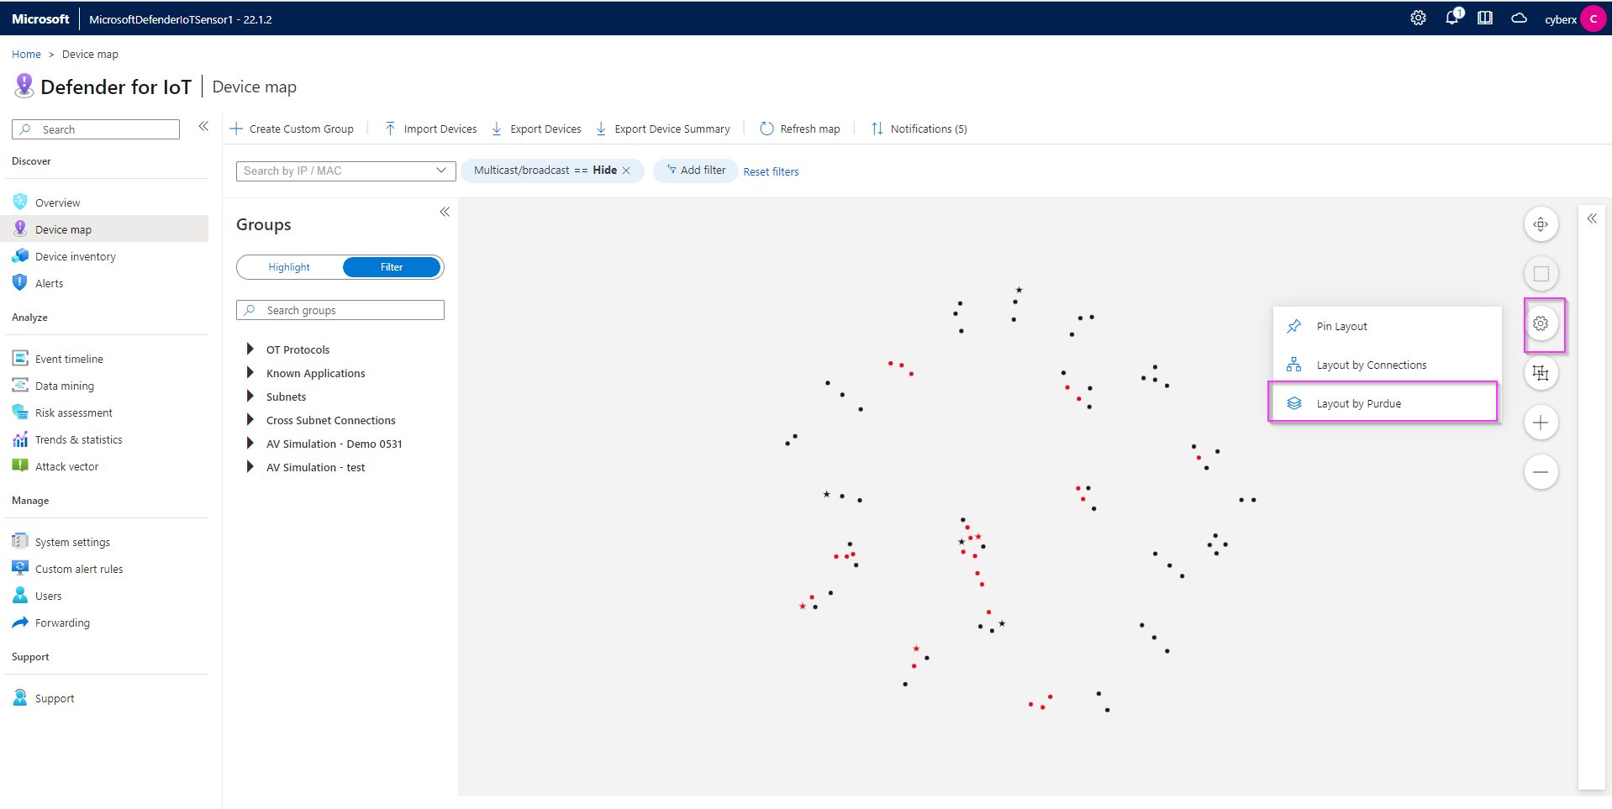

1. Once you confirm the changes, you will see the devices laid out as shown in the image below.

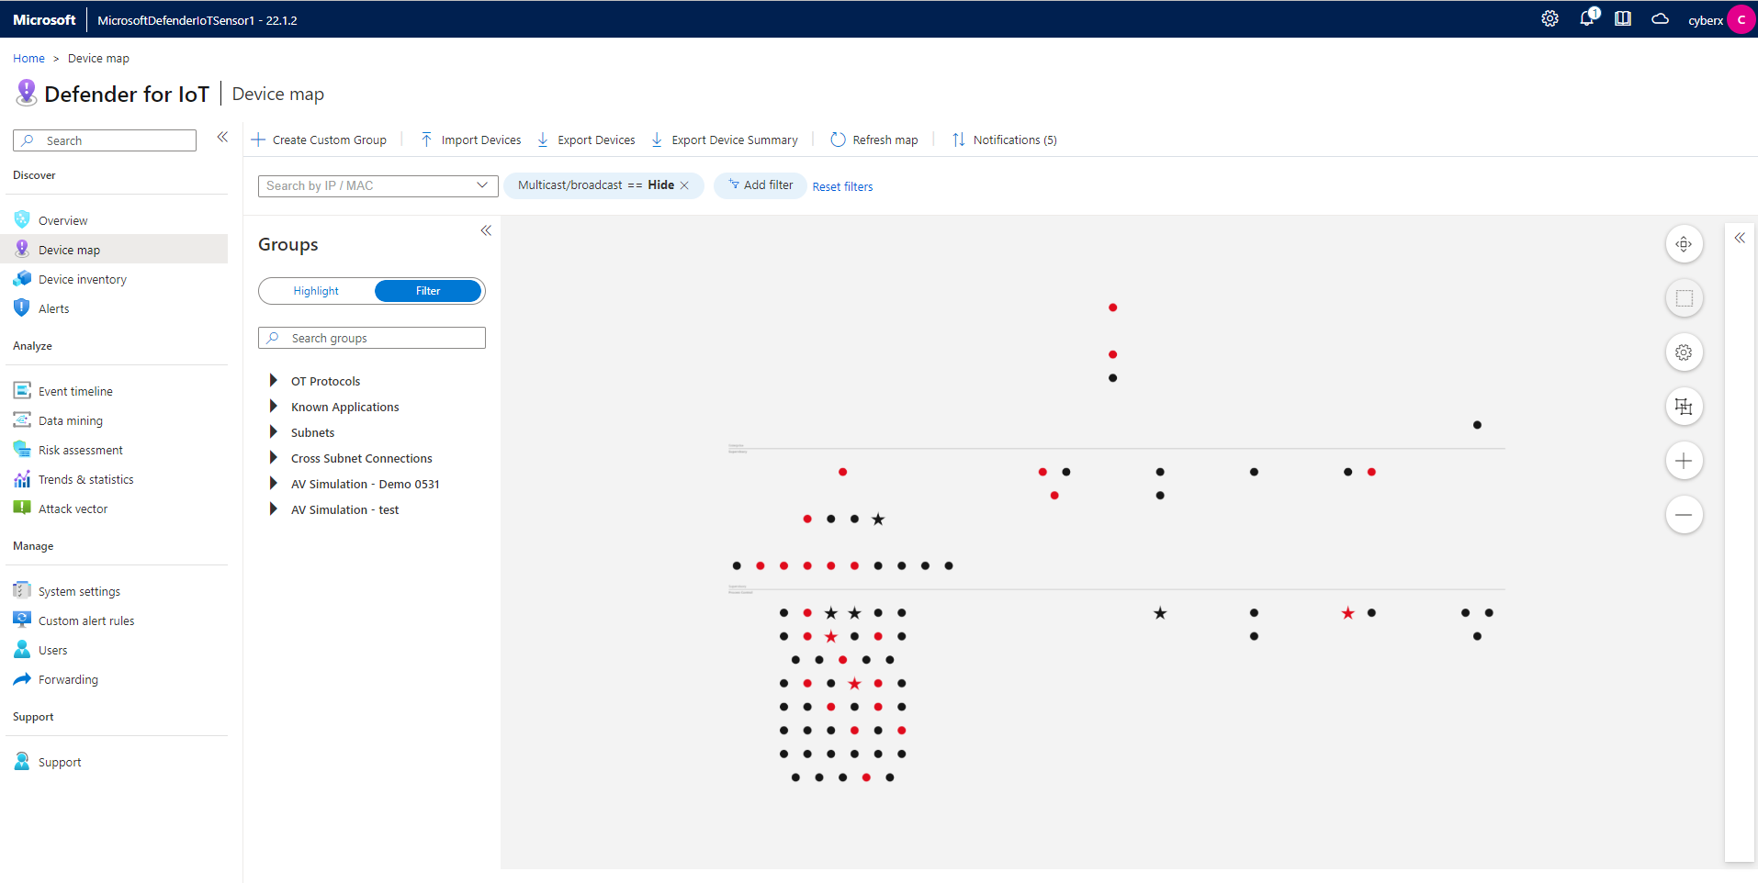

1. Right click on any device (represented by a dot) to view properties, show related events, alerts, reports or simulate attack vectors.

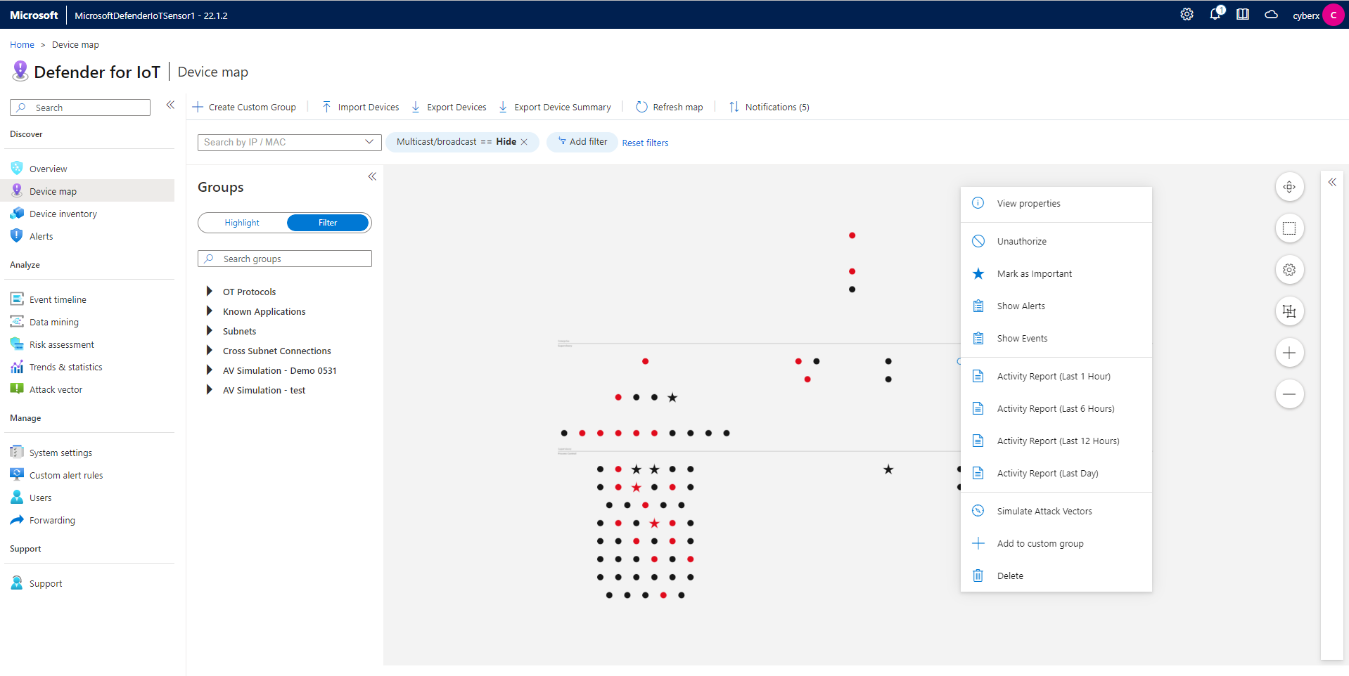

5.To filter by OT Protocols, expand the arrow, and pick the protocol you want to filter by. The console will display the devices that match the filter.

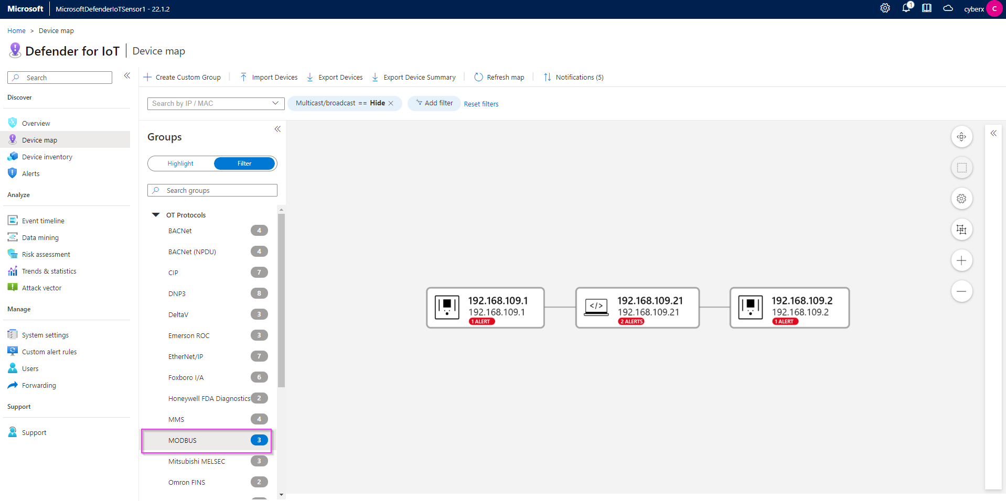

## Task 2: View the associated Alerts

1. Right click on any device that has an Alert associated with it and click on “**Show Alerts”**.

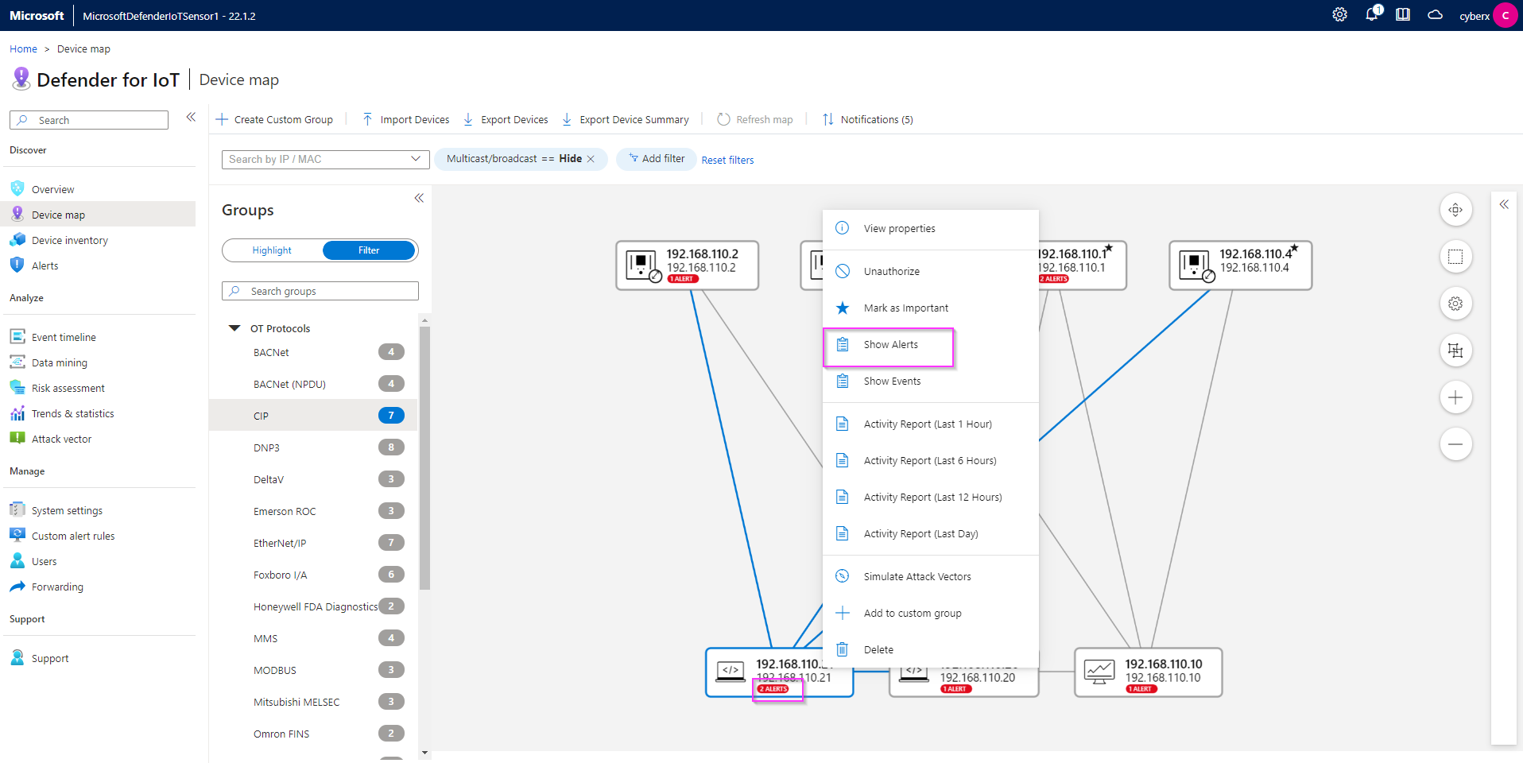

1. The Alerts page helps you identify some important data about the alert, like Alert Severity, Engine, Detection time, as well as the Source Device IPs. It also displays general information about the type of device, network interfaces and protocols.

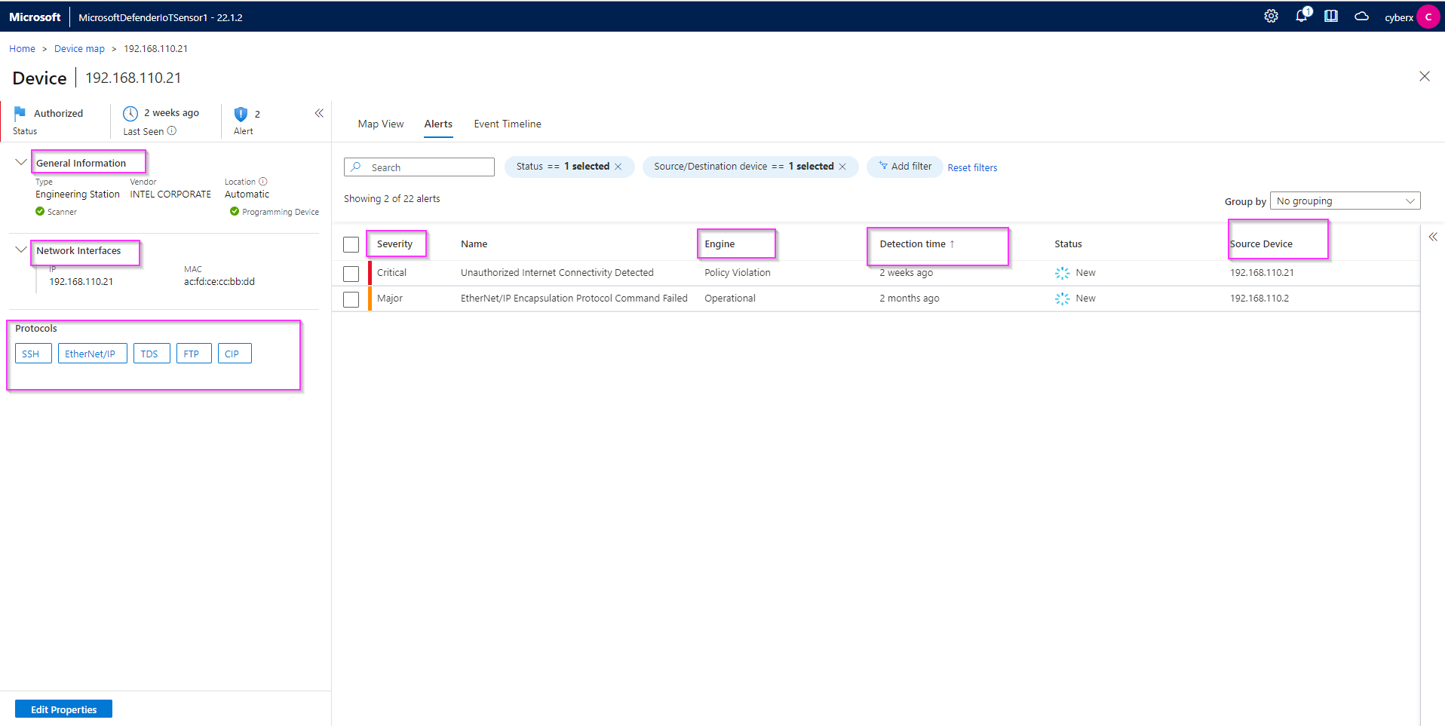

3.To view more details about the Alert and/or to take remediation actions, select the Alert by checking the box beside it, and picking either **“View Full Details”** or **“Take Action”.**

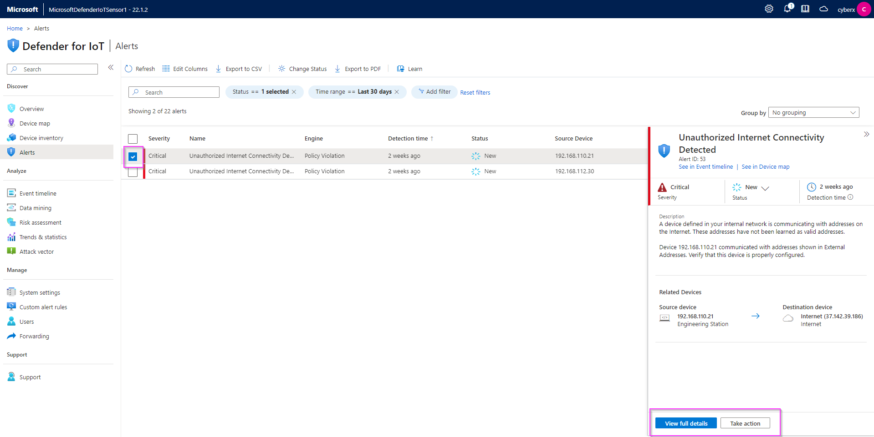

4.You can view all the alerts on your sensor by clicking on the **Alerts** option on the menu on the left. Make sure all the filters are removed. You can group the alerts by picking an option from the **“Group by”** dropdown.

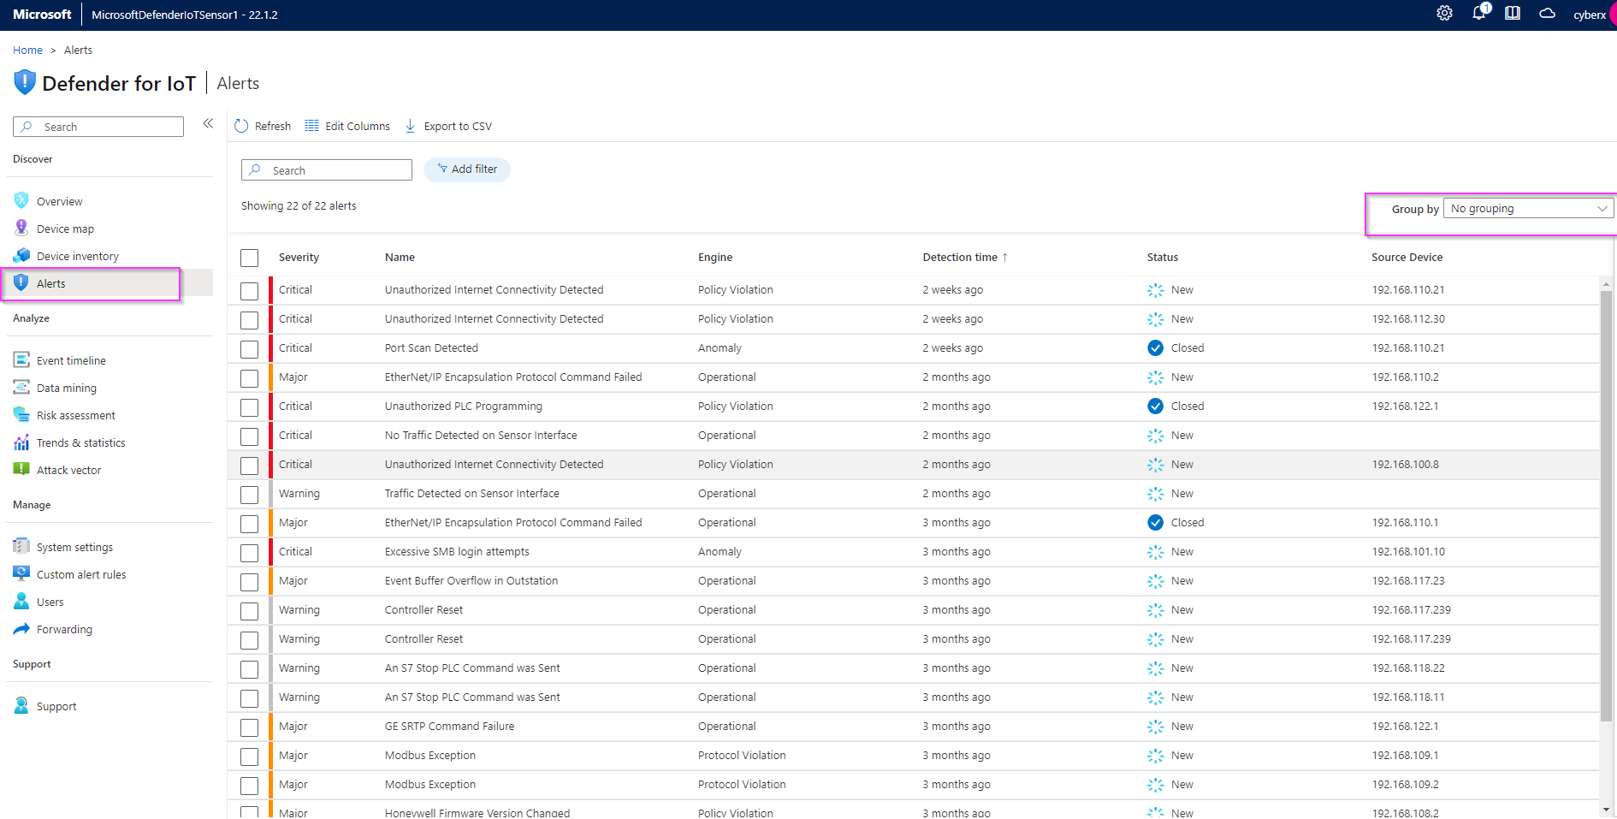

## Task 3: Device Inventory

1. This view allows you to see all the devices connected to your sensor as a list. To filter, click on “Add filter” on the top. For example: the “**Is Authorized**” will show you devices that are either authorized or unauthorized depending on value (True or False) you choose.

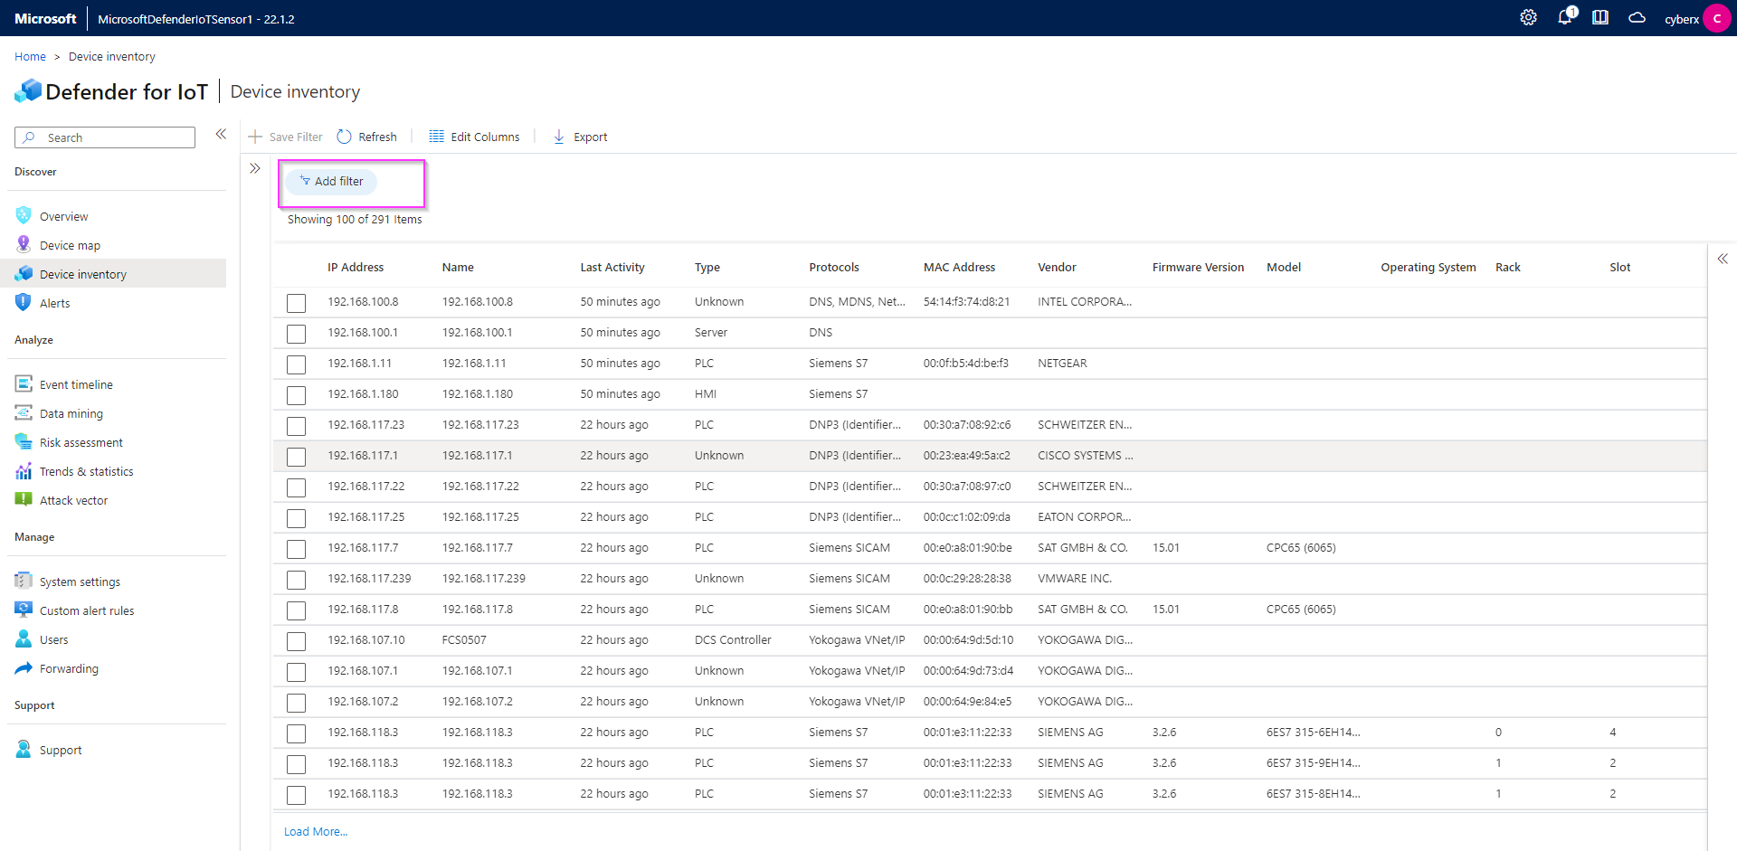

1. You can export the list to a csv file.

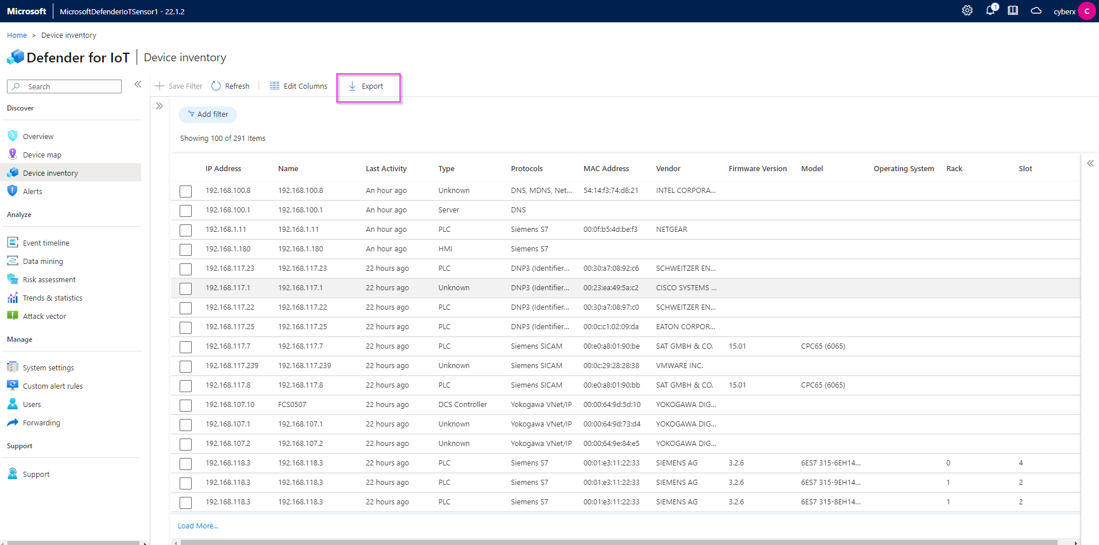

## Task 4: View the Event Timeline

1. This view will allow you a Forensic analysis of your alerts. You can choose to Hide or Unhide the User Operations or select more filter types from the “Add filter”.

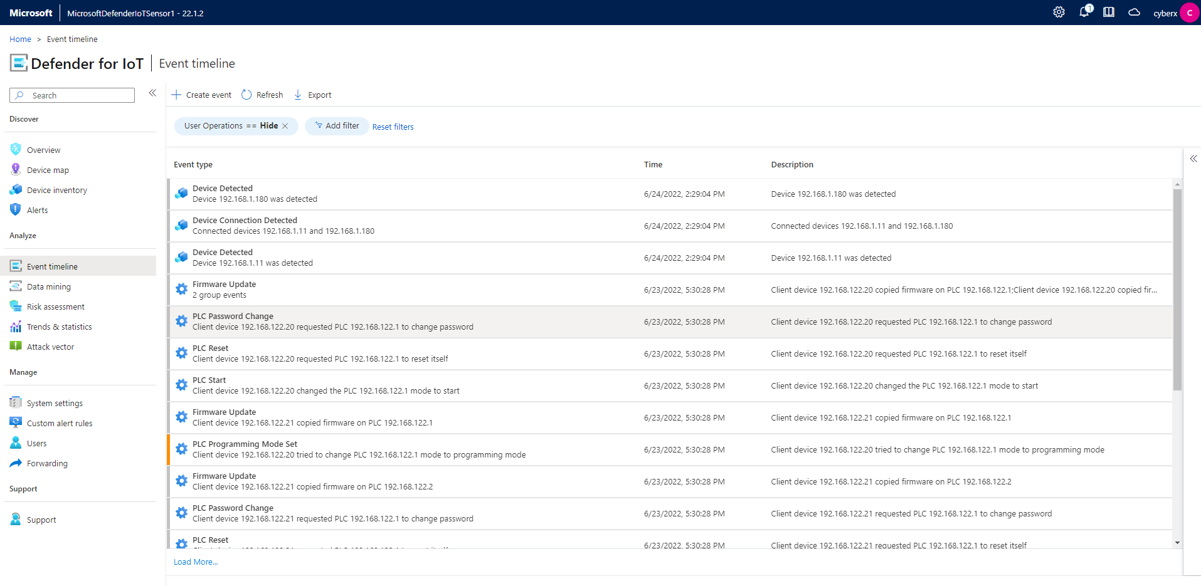

## Task 5: Data Mining

1. In this section you can create multiple custom reports. As an example, we will create a Report based on firmware updates versions. Click on + Create report to open the wizard.

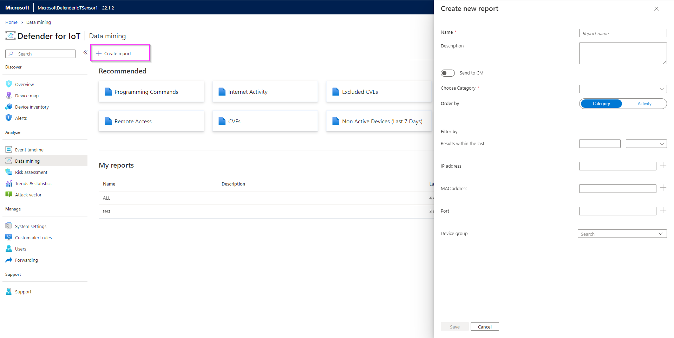

1. Assign a name and a description to your report. Pick **“Modules and Firmware Versions”** for Category, select **“Firmware Version (GENERIC)”** from **“add filter”.**

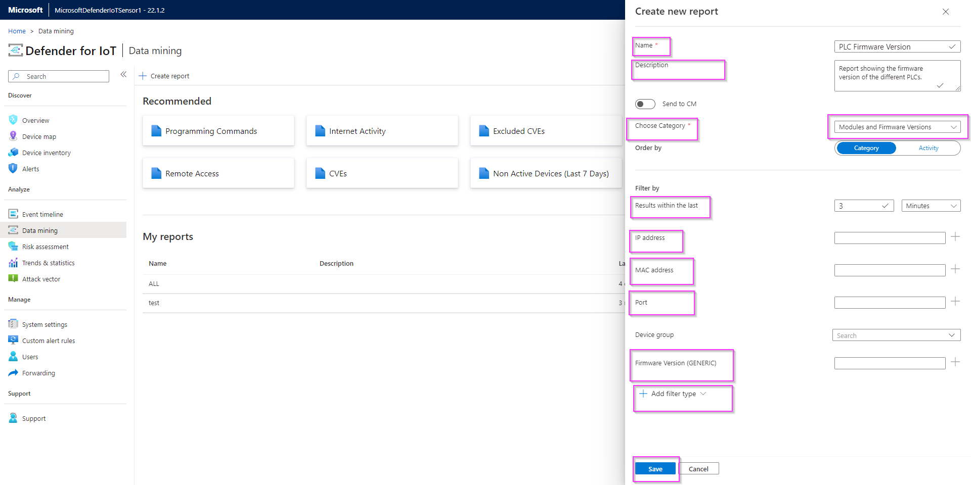

1. Your report will show up on the list under “My reports”.

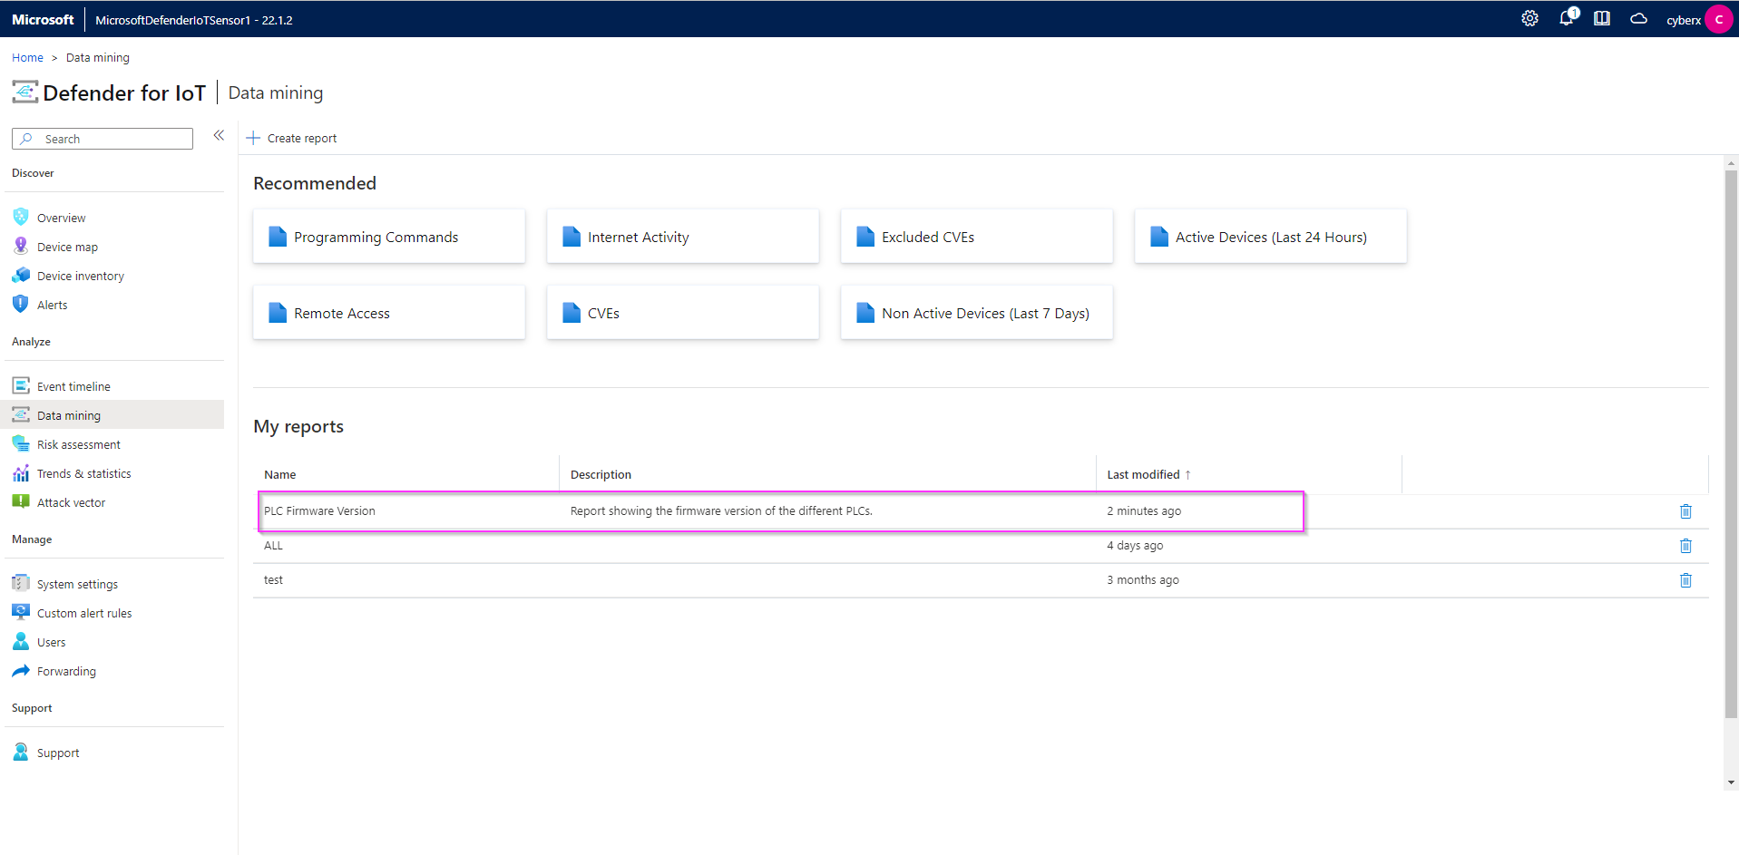

1. You can export the report as pdf or csv.

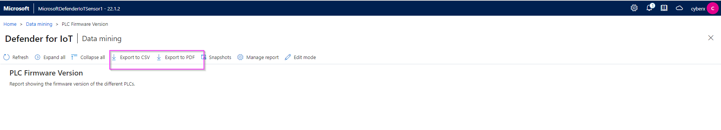

## Task 6: Generate a Risk Assessment report

1. On the Risk assessment page, run the assessment by clicking the “Generate report” button. You can download and view the report as pdf.

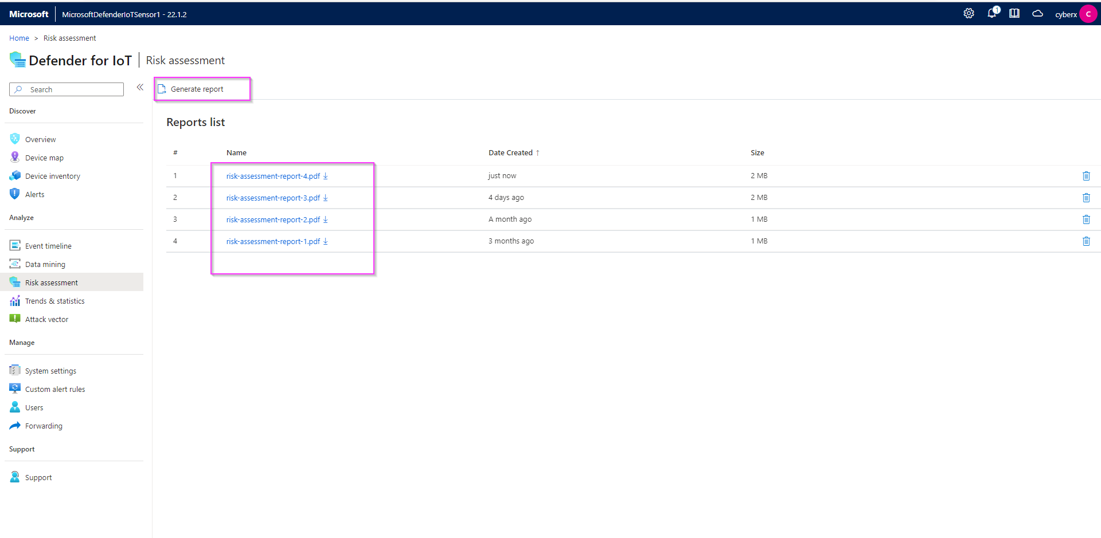

# Exercise 5: Cloud Connect your sensor

## Task 1: Create the cloud connected sensor on the Cloud Management portal

1. On the cloud management (Azure) portal, navigate to “Sites and sensors” and click on “Onboard OT sensor”.

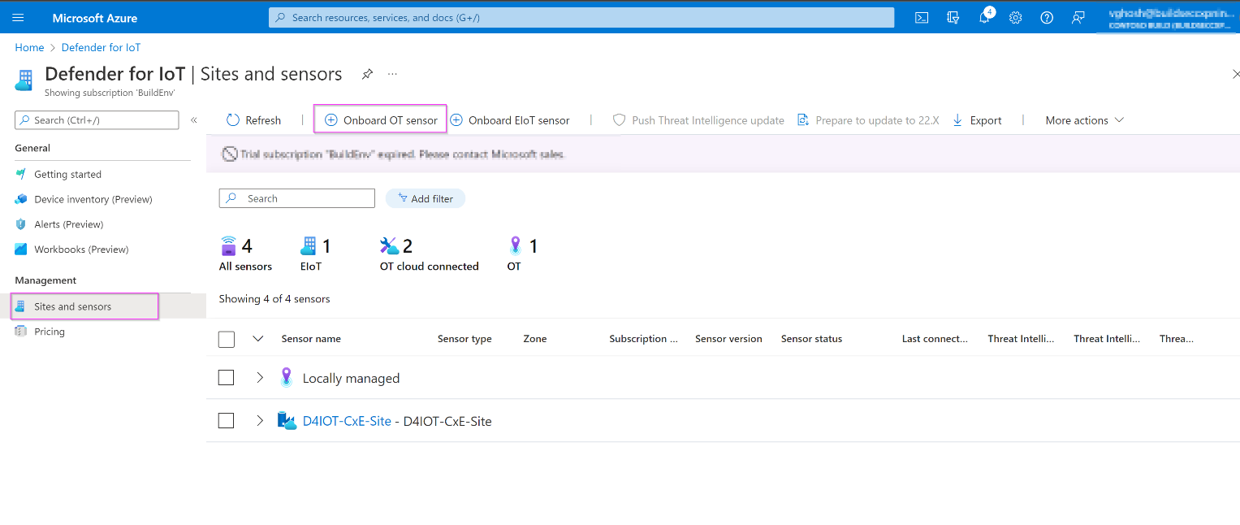

1. Give the sensor a meaningful name, pick the subscription from the dropdown menu, and ensure that “cloud connected” is checked. Click on “Register”.

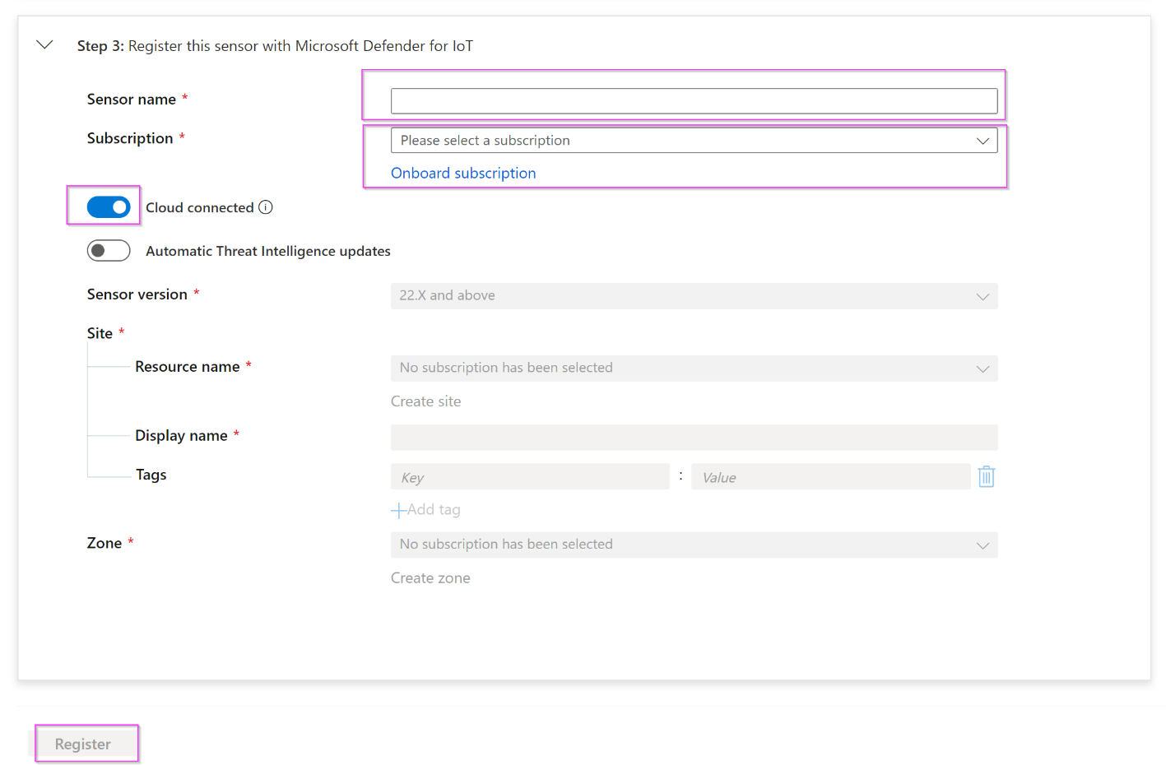

1. The download for the activation starts immediately. Please check your downloads.

## Task 2: Upload the activation file to cloud connect your sensor.

1. Navigate back to your sensor and click on “System settings” -> “Sensor management” -> “Subscription and Activation Mode”.

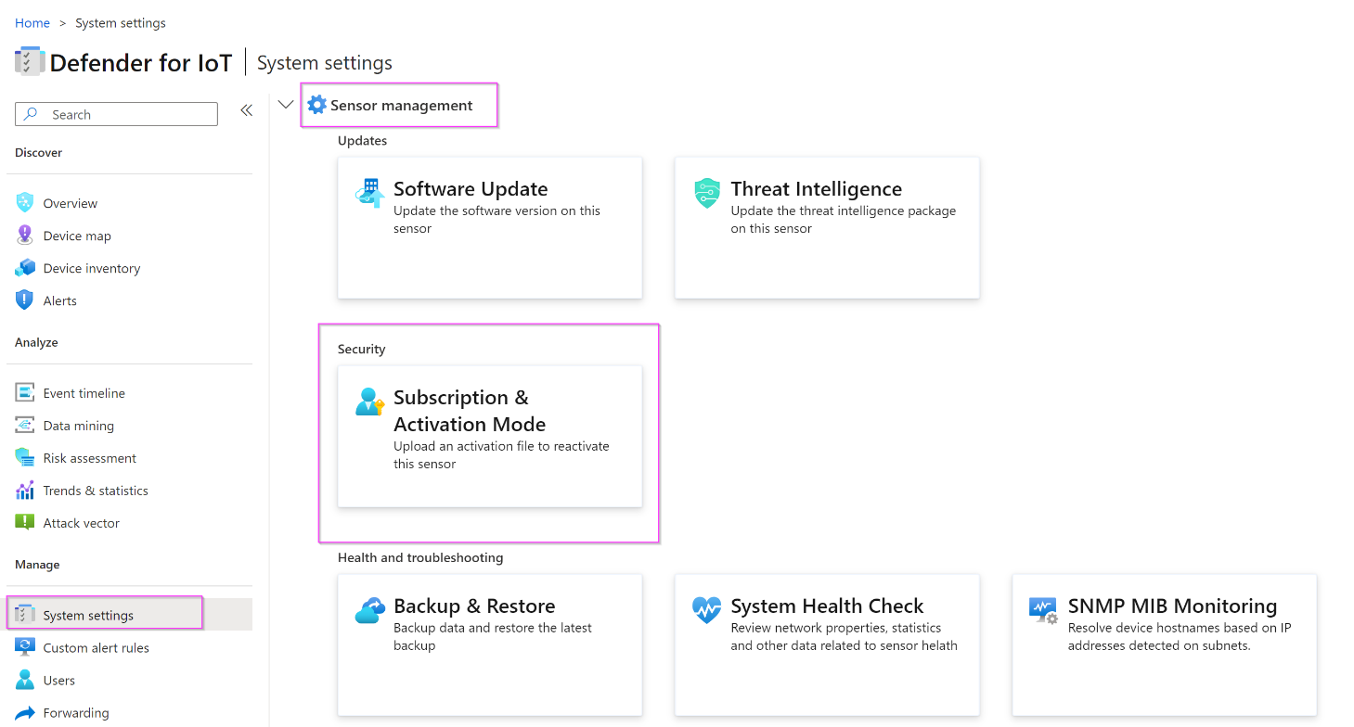

1. Upload the activation file you downloaded in the previous step. Click on “Activate”.

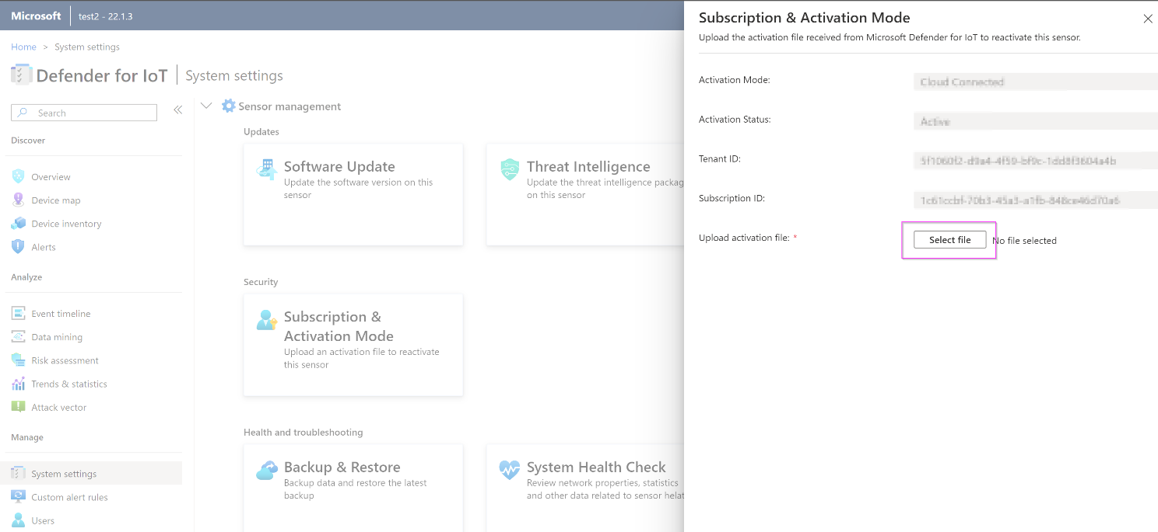

## Task 3: Verify Cloud connection

1. On the sensor console.

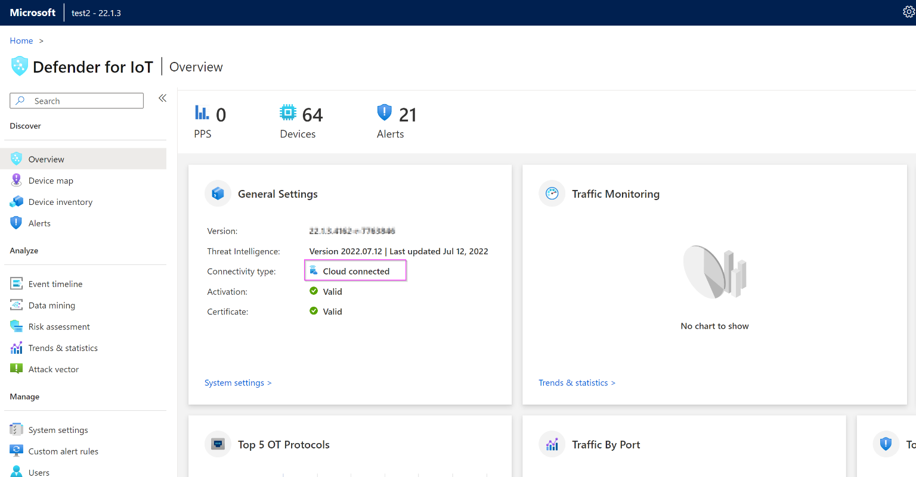

1. On the Cloud management console.

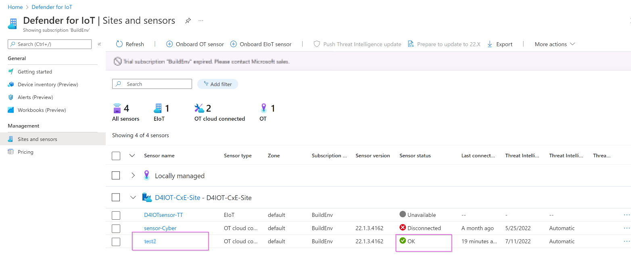

# Exercise 6: Integrate with Microsoft Sentinel

## Task 1: Connecting Data Connectors

1. On the Azure portal, search for **Microsoft Sentinel.**

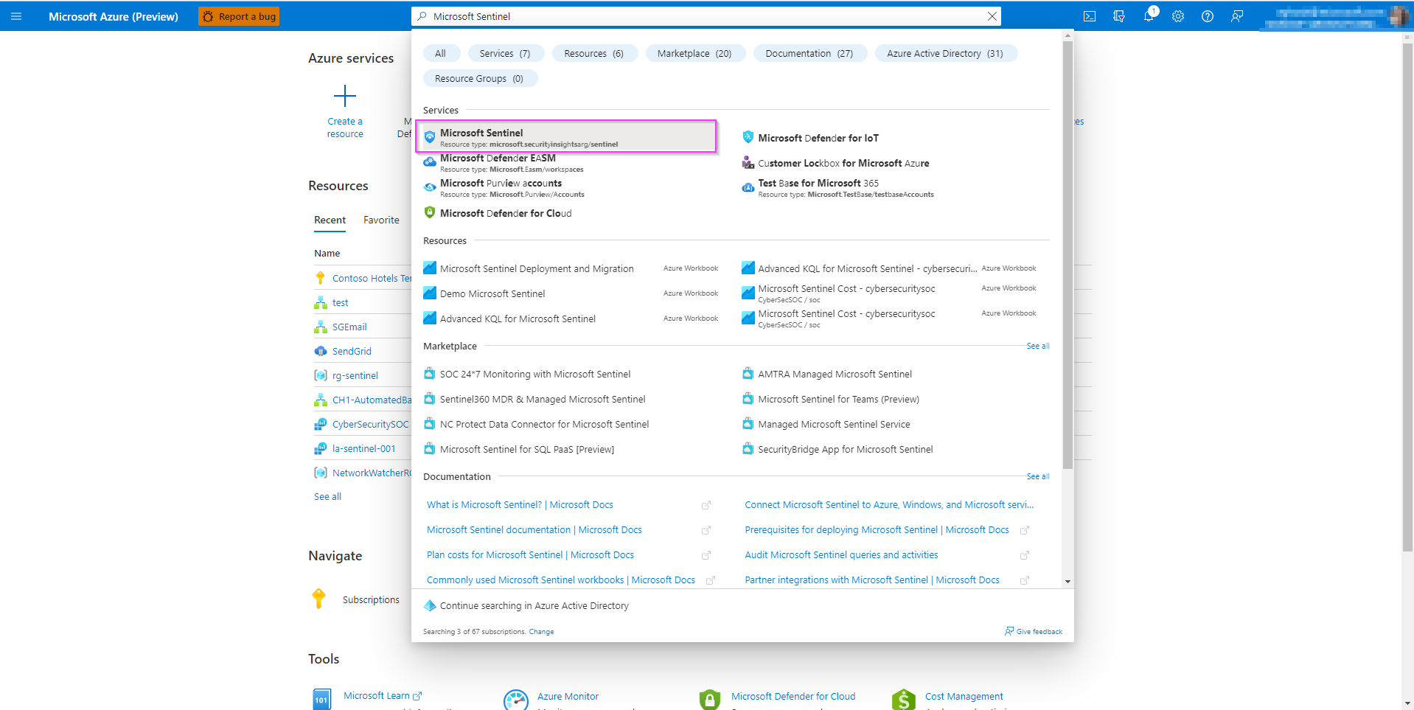

1. Create a new workspace.
2. Go to Configuration > Data Connectors > Search **Microsoft Defender for IoT** to connect Microsoft Defender for IoT to Microsoft Sentinel.

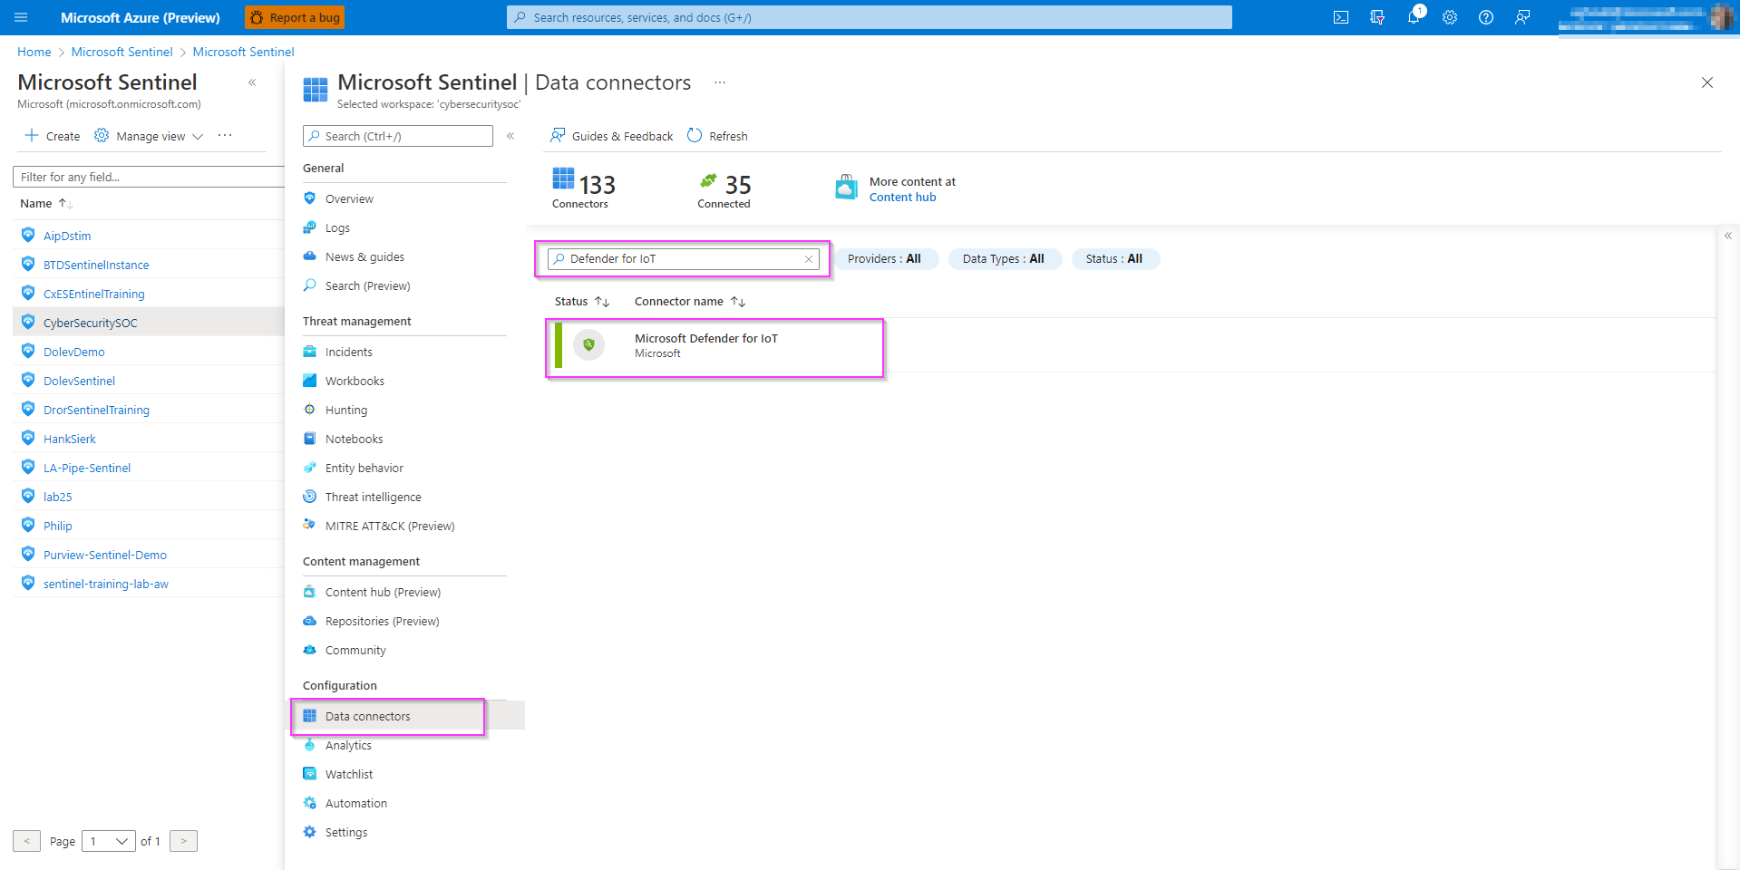

1. Click the **Open Connector Page.**

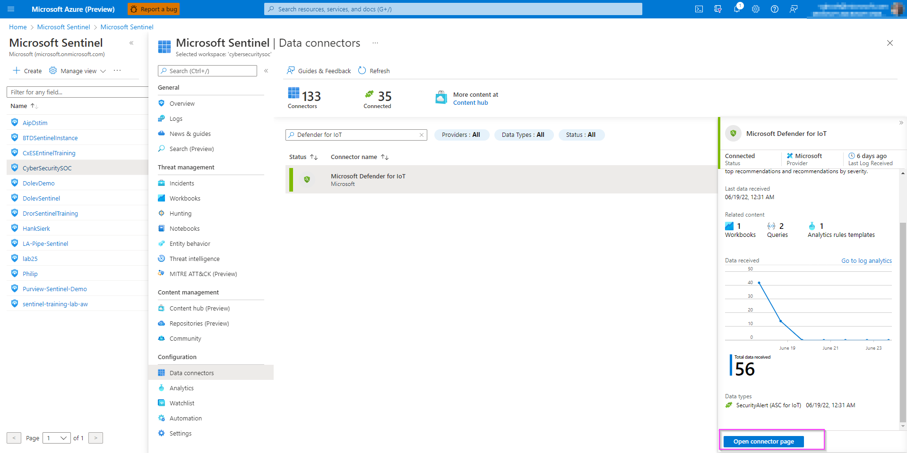

1. Review the instructions and click the “**Connect**” button to connect Microsoft Defender for IoT to Sentinel. If the connection continues to fail, this will most likely be due to the user not having the **"Contributor"** permissions and you may have missed the access step in the prerequisites.

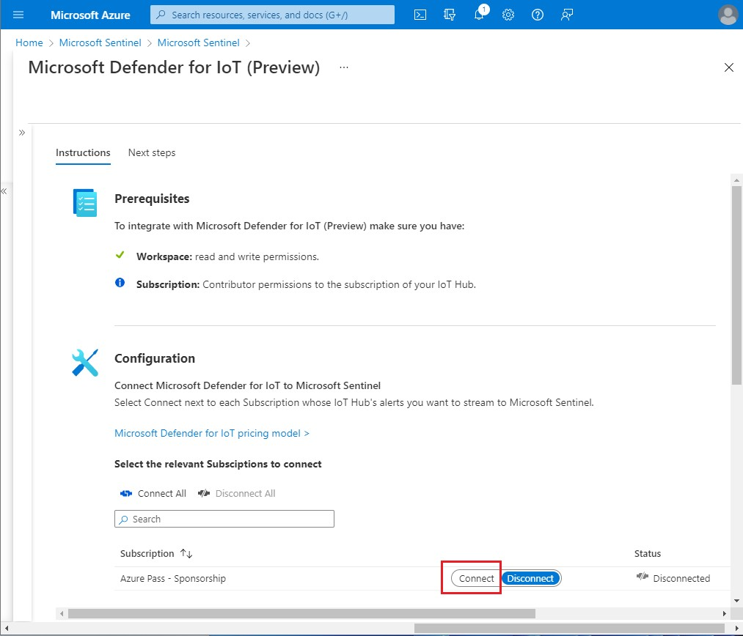

1. If connected correctly you should expect to see the Status change to “**Connected”** and the link light up green.

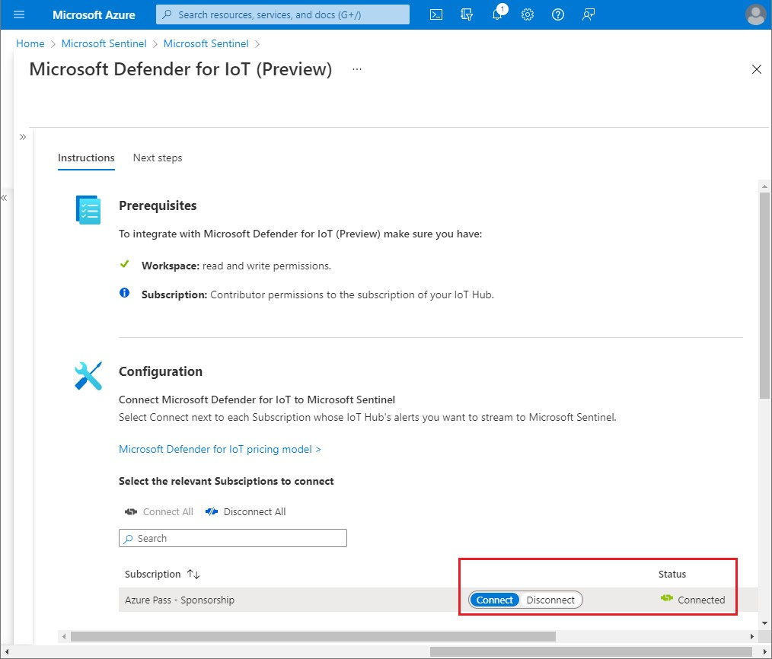

7.Click on **“Next steps”** tab to enable Out of the Box alerts and Workbooks 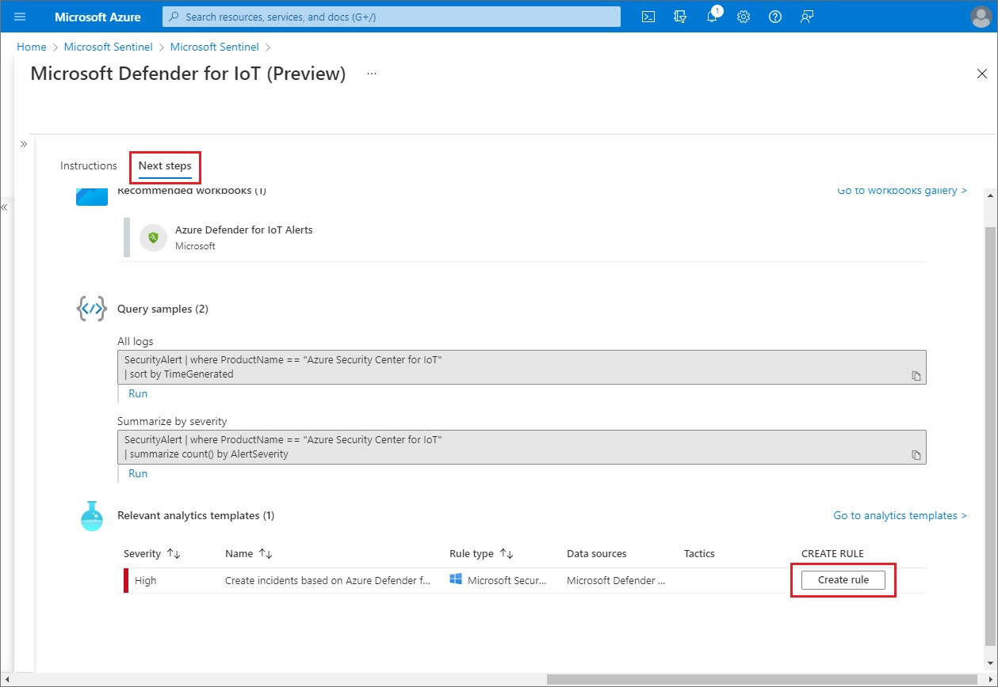

1. Fill in the “Name” and click **Review and Create**, followed by **Create**. This is enabling incidents to be created based on the Azure Defender IoT alerts that are ingested into Sentinel.

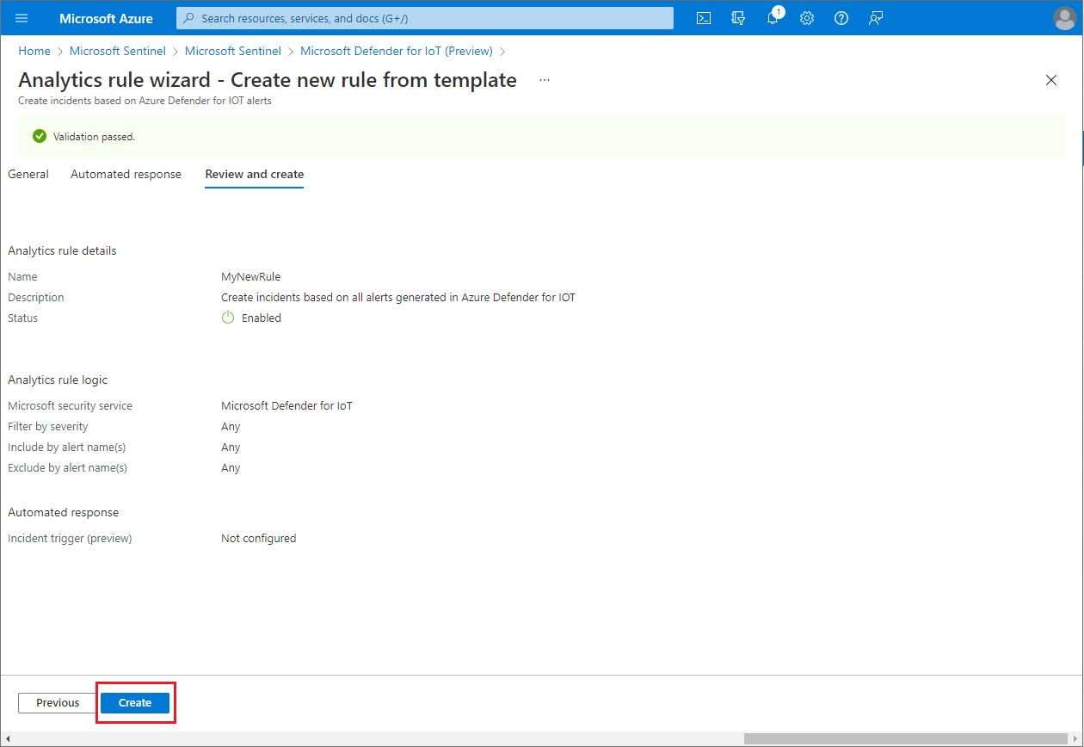

1. Additionally, you can create the rule not only on the data connectors page but also on Microsoft

Sentinel **“Analytics”** blade. Go to the **“Rule Templates”** tab and filter data sources by “Microsoft Defender for IoT” to see all the alerts from the IoT connector.

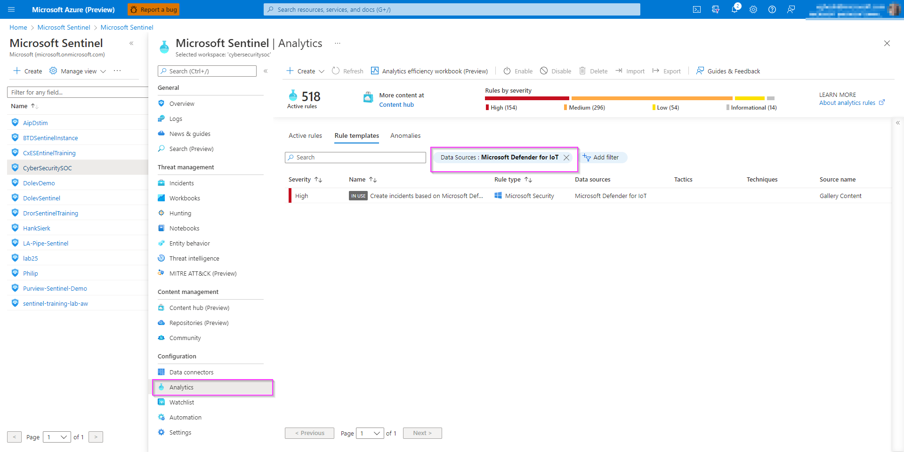

## Task 2: Acknowledge Alerts and Re-run PCAPs

1. Go back to your sensor console, select all the alerts, and click on **“Learn”.** The reason we are doing this is so we can re-run the alerts to show how they are sent and analyzed by Sentinel.

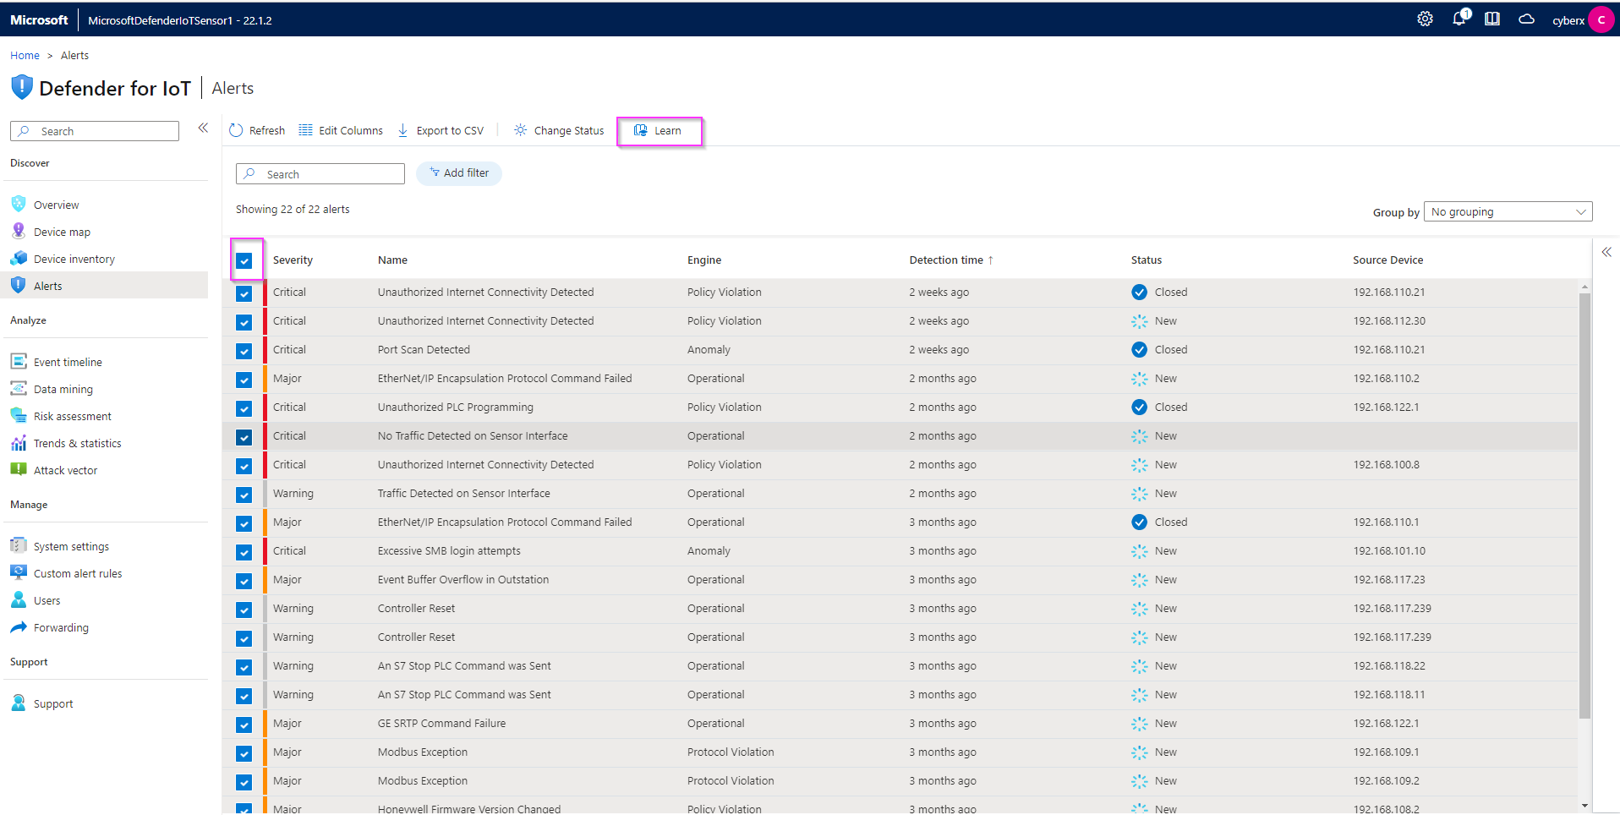

1. From the **System Settings** tab, Click the **Play All** on the PCAP Files to replay simulating the alerts.

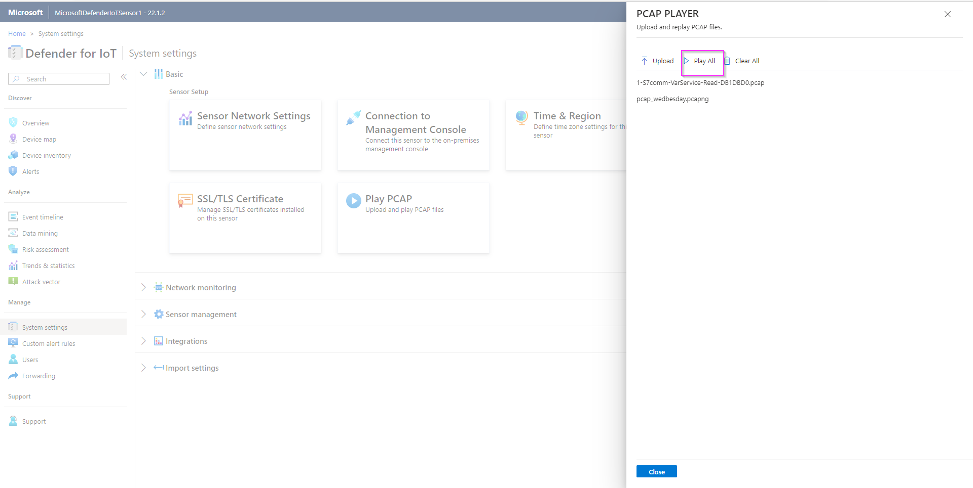

## Task 3: Sentinel interaction with IoT Incidents

1. Go back to the Sentinel console and under the **Threat Management** section, select the **Incidents** tab.

Filter by Product Name **Azure Defender for IoT**.

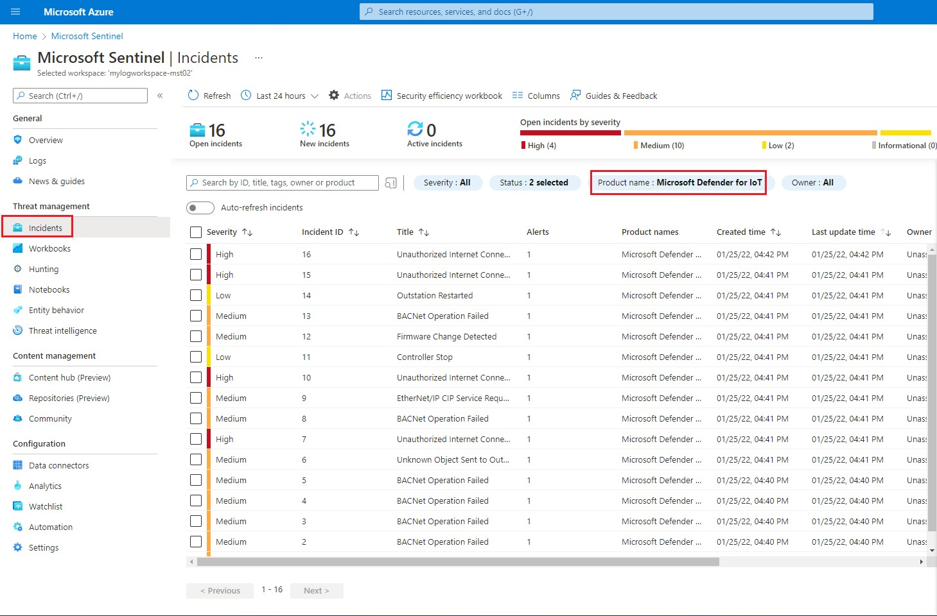

1. Select one of the alerts and click **View full details**

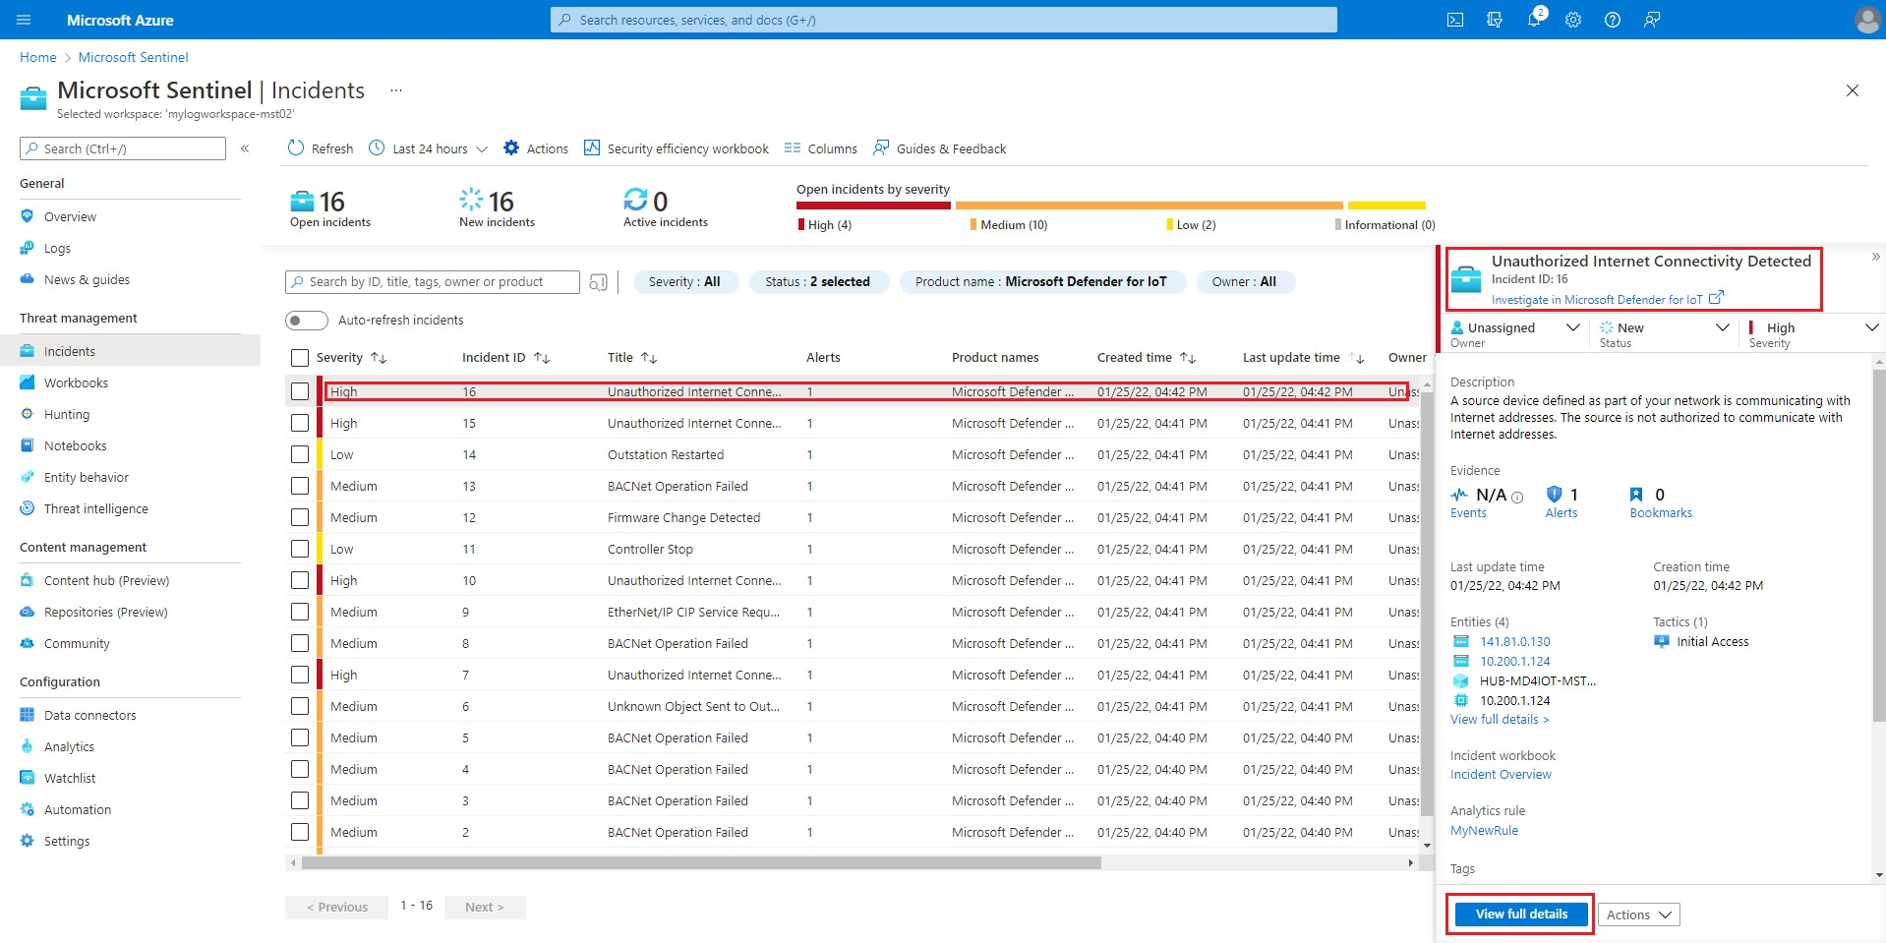

1. It will take you to this screen to get all the information relative to the incident. This allows analyst to get more details on the entity including what other alerts made up the incident, playbooks to enrich the context of the alert, and comments section to leave details on what the analyst discovered during review or how they came to the determination to dismiss the incident.

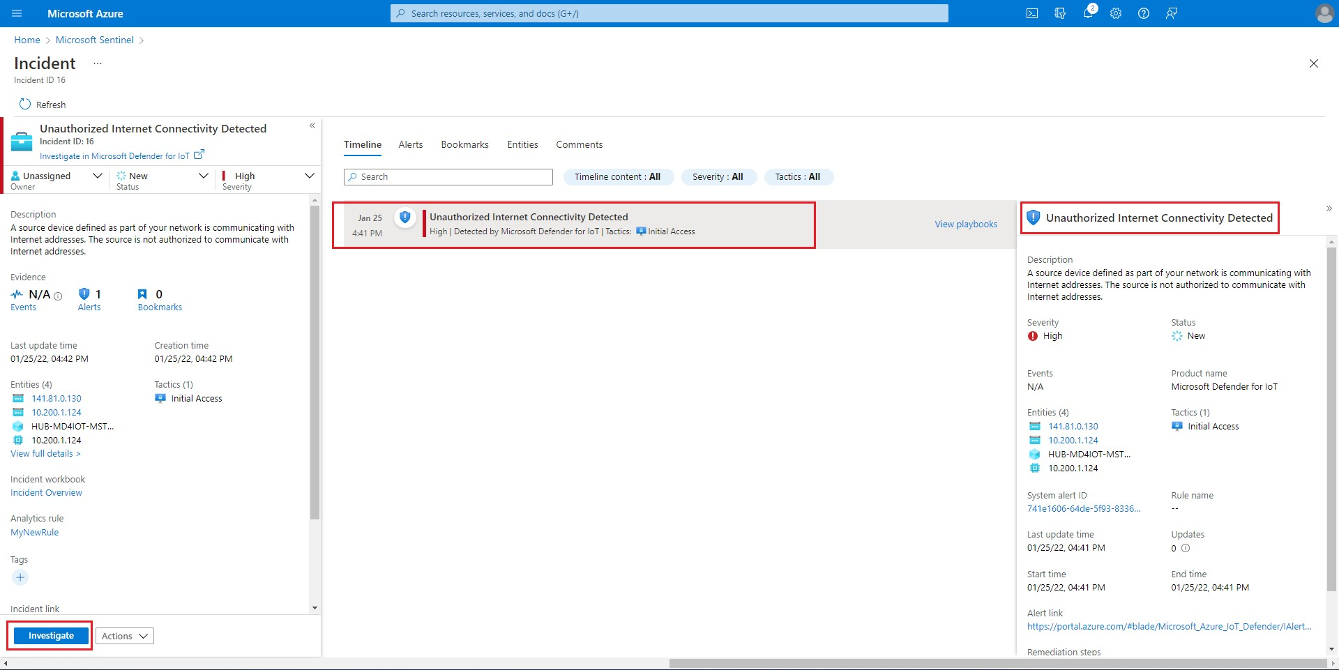

1. By clicking the **Investigate** button, you can dig deeper in the cause of the incident and the relation to other incidents.

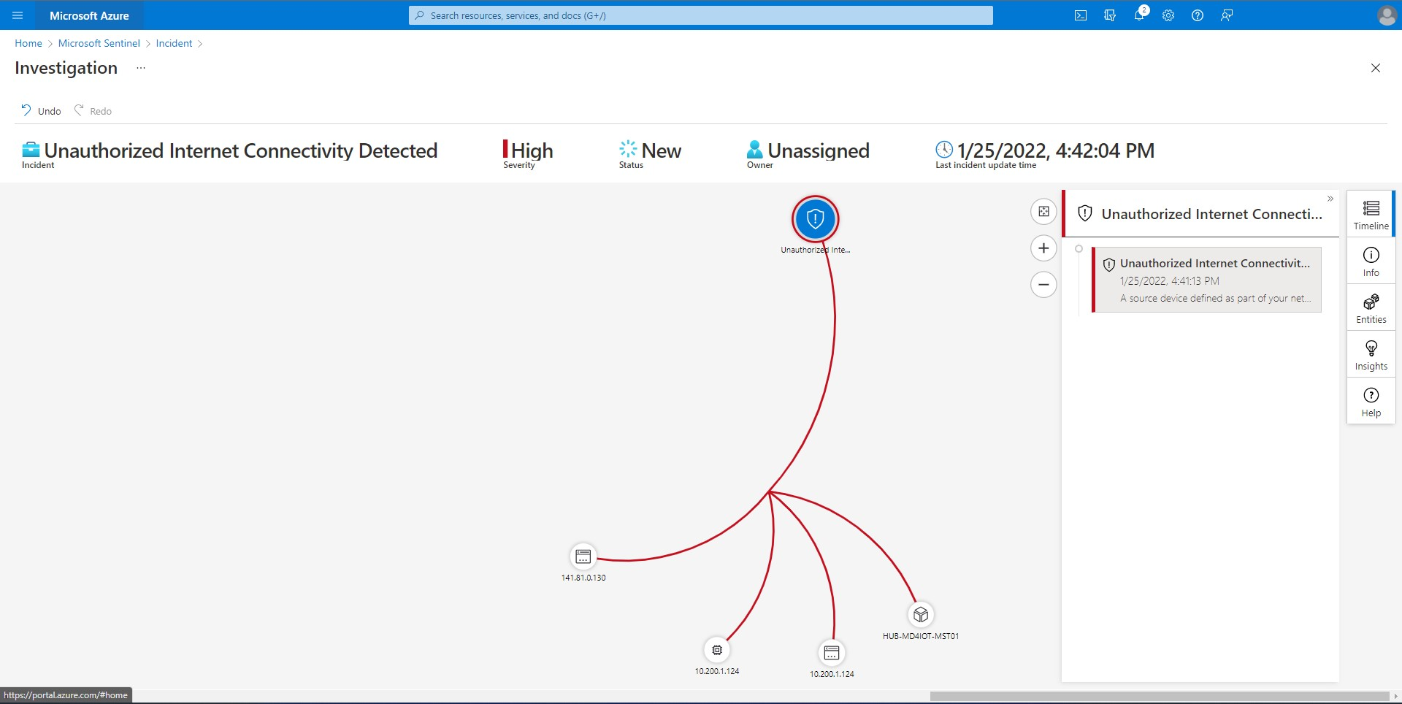

## Task 4: Kusto Query Language to Find Alert Details

1. Navigate to the **“Logs”** tab and run the queries provided below, and view the results.

SecurityAlert | where ProviderName contains "IoTSecurity"

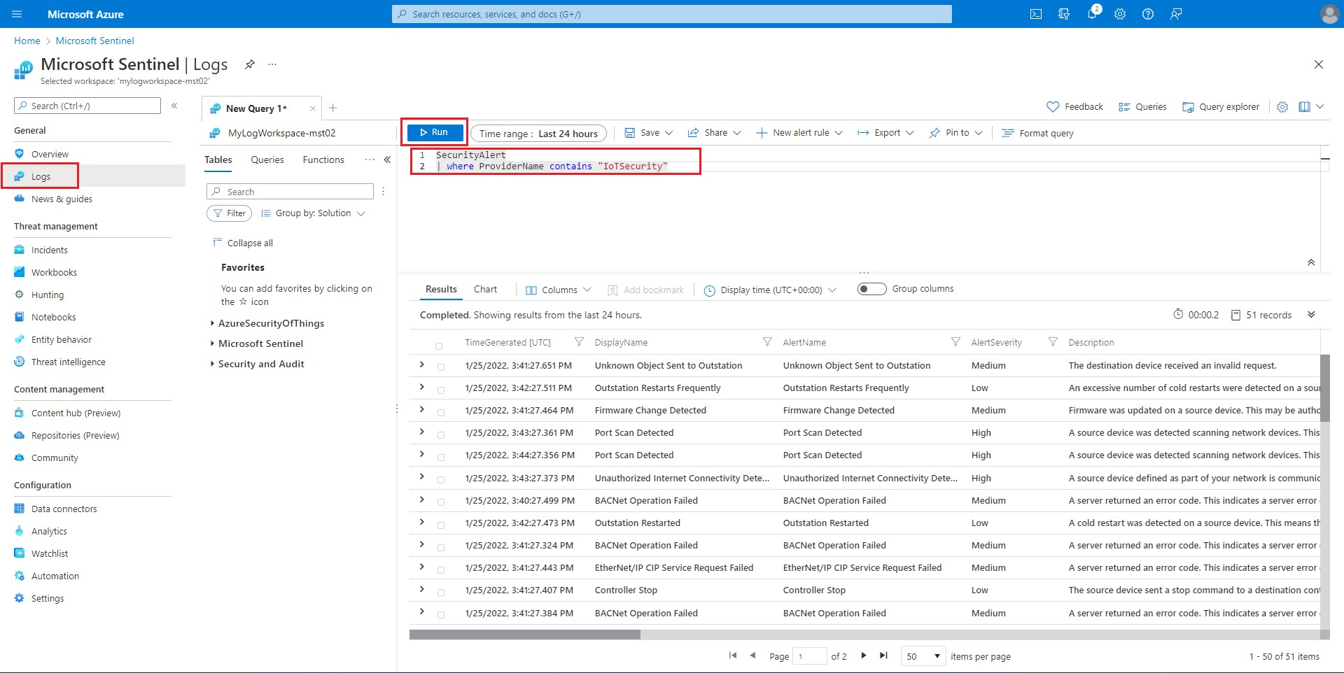

SecurityAlert | where CompromisedEntity == "hub-md4iot-mst01"

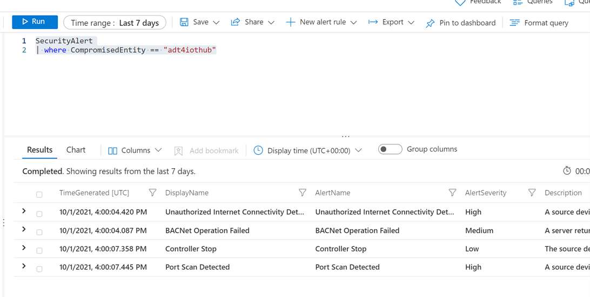

# Exercise 6: Clean Up

## Task 1: Delete resources

The Azure Passes will allow you to run the services for 90 days for training purposes. Although it is a best practice to delete all your resources after the training.

Search for the Resource Group created for this training.

Select Delete resource group on the top right side.

Enter your-resource-group-name for **TYPE THE RESOURCE GROUP NAME** and select Delete. This operation will take a few minutes.

After that is done go to Microsoft Defender for IoT and deactivate the subscription.